

**College of Public Health and Health Professions**

**Department of Clinical and Health Psychology**

**Doctoral Program in Psychology with a Concentration in Clinical Psychology**

**Graduate Student Handbook**

TABLE OF CONTENTS

**OVERVIEW OF CHP DOCTORAL PROGRAM**

*General Timeline* 6

*Important Websites* 6

**florida residency REQUIREMENTS**

*Academic Residency Requirements* 7

*Procedures for Establishing Residency* 8

**ETHICAL CONDUCT**

*Ethical and Professional Standards to Know* 9

*Trainings/Readings Required* 9

*Protected Health Information* 9

*Health Insurance Portability and Accountability Act of 1996 Violations* 9

*Publications* 9

*Professional Practice* 10

*Online Behavior* 10

*Technical Standards*10

**funding & outside employment**

*Funding Sources and Responsibilities* 11

*Graduate Assistantships and Fellowship Required Credits* 11

*Fees* 11

*Health Insurance* 12

*Outside Employment* 12

*CHP Trainee Emergency Fund* 12

**milestones & committees**

*Graduate Advisement & Supervisory Committees* 13

*Types of Committees* 13

*Duties of the of the Master’s Thesis and Doctoral Committees* 13

*Process for Forming Committees* 13

*Special Appointment of a Committee Member* 13

*Physical Presence Expectations at Milestone Meetings* 13-14

*Food and Beverage Policy at Milestone Meetings* 14

**First Year Project & Master’s Thesis**

*Overview of the First Year Project and Master’s Thesis* 15

*Master’s Thesis Committee Members* 15

*Documentation Needed to Finalize the Master’s Thesis Committee* 15

*Deadlines* 15

*What Happens After You Successfully Defend?* 15

*First Year Project & Master’s Thesis Timeline* 16

*What Happens if I Defend My Master’s Thesis After March of My 2nd Year* 17

*What if I Completed a Master’s Thesis Prior to Admission to the University of Florida?* 17

**establishing the doctoral committee**

*Doctoral Committee* 18

*Doctoral Committee Requirements* 18

*Doctoral Committee Members* 18

*Documentation Needed to Finalize the Doctoral Committee* 18

**doctoral Qualifying examination timeline & guidelines**

*Doctoral Qualifying Examination Timeline* 19

*University of Florida Graduate School Requirements* 20

*Administration of the Doctoral Qualifying Examination* 20

*Required Timeline Between Oral Defense of Qualifying Exam and Date of Degree* 20

*What if I Need to Remediate My Written Doctoral Qualifying Examination* 20

*Documentation Needed to Finalize the Doctoral Qualifying Examination* 20

*Table: Planning Phase with Mentor* 21

*Table: Writing Phase* 21

*Table Format Guidelines – Final Written Exam* 22

*Table: Distribution of Written Exam* 23

*Table: Grading of Written Exam* 23

*Table: If Written Exam is Not Passed* 23

*Table: Breadth of Oral Examination* 23

**doctoral dissertation**

*Dissertation Process* 24

*Dissertation Proposal Meeting* 25

*Is the Dissertation Proposal a Formal Graduate School Milestone?* 25

*Purpose of Dissertation Proposal Meeting* 25

*What Happens During the Dissertation Proposal Meeting?* 25

*Dissertation Defense* 25

**overview of course requirments RELATED TO COMPETENCIES IN DISCIPLINE-SPECIFIC KNOWLEDGE & PROFESSION WIDE COMPETENCIES**

*Area of Concentration Courses* 26

*Required Courses* 26

*Course Schedule* 26

*CLP 6905 (Individual Work; Directed Individual Study)* 26

*CHP 5-Year Teaching Plan* 26

*Total Credit Hours Required for the Ph.D.* 26

*Retain Copies of Syllabi* 26

*Didactic Training* 26

*Public Health Courses* 26

*Putting Families First* 26

*What if I Took Courses Prior to Being Admitted to UF?* 26

*Courses Required of All Students to Meet Competency in Discipline-Specific Knowledge* 27

*and Profession-Wide Competencies*

**Research**

*Research Mentorship Policy* 28

*Outside Research Activities* 28

*Counting Research Hours toward Internship Hours* 29

**practicum requirements & clinical Competencies**

*Overview* 30

*Practicum Schedules* 30

*Practicum Length* 30

*Supervision* 30

*Practicums Outside of the UF Health Psychology Specialties Clinic* 30

*Clinical Hours Tracking* 30

*How to Categorize Psychological Diagnostic Evaluations: Assessment or Intervention Hours?* 31

*Evaluations of Students in the Competencies in Professional Psychology* 31

*Clinical Progress Committee* 31

*Unsatisfactory Progress Toward Clinical Competencies* 31

*Clinical Supervisor Evaluations* 31

*Training in Delivering Clinical Supervision* 31

*Types of Practicum* 32

**CLINICAL SUPERVISION**

*Local Direct Supervision* 33

*Remote Direct Supervision* 33

*Remote Service Delivery* 33

*Supervision by Unlicensed Faculty and Post-Doctoral Associates* 33

**INTERNSHIP REQUIREMENT**

*How Do I Know if I Can Apply for Internship?* 34

*Preparing to Submit Internship Applications* 34

*When to Apply* 34

*Where to Apply* 34

*Applying to Non-APA Accredited Internships* 34

*Credit Requirements While Completing Internship* 34

**EVALUATION METHODS**

*Program Evaluations* 35

*Student Contributions* 35

*Mentoring Meetings* 35

*Faculty Evaluations of Students* 35

*Table: Evaluation Components* 35-36

*Student Evaluations of Mentor* 36

*Maintaining Student Confidentiality Policy* 36

**standards of performance AND Remediaton­­­­­­­­­­­__________**

*Scholarship* 37

*Research* 37

*Professional Development* 37

*Remediation Associated with Problems in Professional Competencies* 37-39

**general policies**

*Academic Health Center Information Security Policy* 40

*Storage of Confidential of Research and Patient Data* 40

*Communication Policies* 40

*Mailboxes* 40

*Letterhead* 40

*UF Logos* 40

*Technology Policies* 40

*Computer Literacy* 41

*VPN Access and Terminal Server Access* 41

*Immunization Requirements* 41

*Dress Code* 41

*Personal Therapy* 41

*Consumer Information Disclosure for License Preparing Programs* 41

*UF Health Directory Profile* 41

*Social Media Policy* 41-42

**leave policies**

*12-Month Program Policy* 43

*Types of Leave* 43

*Leave Due to Illness or Emergency* 43

*COVID-19 Leave* 43

*Clinical Leave Notification Policies* 43-44

*Advanced Practicum Coverage* 44

*Holiday Leave* 44

*Emergency Closures* 44

**conflict resolution**

*Procedures for Handling Conflict* 45

**reporting bias or hate crimes**

*RESPECT Team* 46

*Reporting Bias or Hate Crimes* 46

*Microaggressions Committee* 46

**OVERVIEW OF THE CHP DOCTORAL PROGRAM**

The Doctor of Philosophy (Ph.D.) is a research degree and is granted on evidence of general proficiency, distinctive attainment in a special field, and particularly on ability for independent investigation as demonstrated in a dissertation presenting original research with a high degree of literary skill. Consequently, doctoral programs are more flexible and varied than those leading to other graduate degrees. The Graduate Council does not specify what courses are required for the Doctor of Philosophy degree. General requirements: the program should be unified in relation to a clear objective, the program should have the considered approval of the student’s entire supervisory committee, and the program should include an appropriate number of credits of doctoral research.

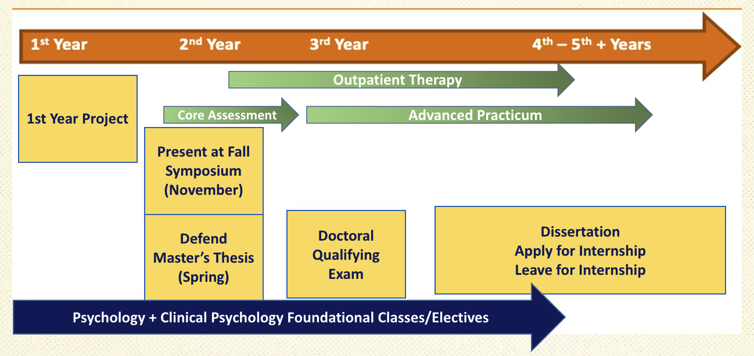**The CHP Graduate Program is a 12-month long program, which means that research, classes, and clinical work occur all year.**

***Important Websites***

[UF Graduate School](http://graduateschool.ufl.edu/)

[UF Graduate School Handbook](http://graduateschool.ufl.edu/media/graduate-school/pdf-files/handbook.pdf)

[UF Graduate School Editorial Office](http://helpdesk.ufl.edu/application-support-center/graduate-editorial-office/)

[UF Graduate School Thesis & Dissertation Deadlines](http://graduateschool.ufl.edu/about-us/offices/editorial/editorial-deadlines/)

[UF General Website](http://www.ufl.edu/)

[UF Graduate School Calendar](http://graduateschool.ufl.edu/graduate-school-calendar/)

[Gator GradCare Health Insurance](http://hr.ufl.edu/benefits/health-insurance/gatorgradcare/)

[My UFL](https://my.ufl.edu/ps/signon.html)

[UF Registrar](http://www.registrar.ufl.edu/forms.html)

[UF Privacy Office](http://privacy.ufl.edu/uf-health-privacy/)

[CHP](http://www.chp.phhp.ufl.edu/)

[UF Policy Statement on Non-Discrimination](http://regulations.ufl.edu/wp-content/uploads/2012/09/1006.pdf)

[UF Disability Resource Center](https://disability.ufl.edu/)

CHP Technical Standards

**ACADEMIC RESIDENCY REQUIREMENTS**

Our Clinical Psychology Program is a 12-month long, 4–5-year program. **It is not a distance-learning program.** Thus, the American Psychological Association requires minimum requirements for graduate students to be physically located in Gainesville (or its surrounding areas). Distance learning (e.g., attending courses on a semester by semester basis from a location other than the immediate Gainesville area) is prohibited.

1. Minimum of 3 full-time academic years of graduate study (or the equivalent) plus internship prior to receiving a Ph.D. from UF.

2. At least 2 of the 3 academic training years (or equivalent) must be in the UF Clinical Psychology program in the Department of Clinical and Health Psychology at to receive a Ph.D. from UF.

3. At least 1 year must be in full-time residence at the program.

To monitor the residency requirement, all students are required to record the date that they moved to the Gainesville area in RedCap. Upon departing for internship, students will record the date that they move away from Gainesville.

**FLORIDA RESIDENCY REQUIREMENTS**

**Students must check with the Academic Coordinator to check residency status upon arrival.**

Any student who does not obtain Florida residency will be subject to out-of-state tuition charges if not receiving a tuition waiver (i.e., the internship year). Thus, it is essential to pursue becoming a Florida resident within the first 12 months of arriving in Gainesville. There will be no exceptions to this rule. Being claimed as a dependent on parental income tax filed in another state may affect your ability to become a Florida resident.

1. Be extremely careful when filling out required forms. Any mistake may cause denial of the application.

2. If your application for residency is DENIED: this is likely due to either an error in the application materials or an error in processing the materials.

* 1. Contact the UF Registrar to determine the reason the application has been denied.
  2. It could very well be that there was a typo or misspelling on the application form.

**Immediately and before the 1st day of classes of the Fall semester** file a Declaration of Domicile in Florida at the Alachua County Civil Courthouse at 201 E University Avenue, phone 374-3636, OR use this link to a PDF form: [Alachua County Declaration of Florida Residency](http://www.alachuaclerk.org/forms/DECLARATION_OF_FLORIDA_DOMICILE.pdf)



3. The fee for recording the Declaration of Domicile form: [Declaration of Florida Residency Fees](http://www.alachuacounty.us/Depts/Clerk/Fees/Pages/RecordingFees.aspx)

4. Mailed forms must be notarized by a Florida notary. All banks have a Notary.

5. Once the form is filed and recorded, they will mail it back to you.

a. This is your receipt proving your intention to change your residency to Florida.

b. Keep this record for future use during the reclassification process.

c. Upload proof of Florida Residency to your REDCap account.

**As soon as possible:**

1) Obtain a Florida Driver's License;

2) Register to vote in Florida and obtain a Florida Voter's I.D.; and

3) Register your car in Florida



6. Keep documents to show when you began living in Florida and your recorded copy of declaration of domicile (e.g., rental agreement, utilities, your admissions letter and LOA.

a. Residency in Florida must be as a bona fide domiciliary rather than for the sole purpose of maintaining a residence incident to enrollment at an institution of higher education. Living in or attending school in Florida will not establish legal residence.

b. Refer to UF's [Graduate Student Handbook](http://graduateschool.ufl.edu/media/graduate-school/pdf-files/handbook.pdf) and the [Graduate Catalog](http://gradcatalog.ufl.edu/) for more information.



**In July of the 2nd Year:**

Complete the [Residency Reclassification/Residency Change](https://registrar.ufl.edu/assets/pdfs/residencyreclass.pdf) and submit it to the UF Registrar.

7. Apply for residency at the Registrar’s Office before the fee payment deadline of the semester in which you wish to establish residency.

b. Often, the application cannot be made until you have resided in Florida 11.5 to 12 months.

c. There are cases that allow for an earlier application and approval (e.g., spouse has been Florida resident for 12 months, spouse works full-time in certain jobs)*.*

*NOTE: This form MUST be completed in sufficient time for their office to process it and make a decision* ***PRIOR*** *to the fee payment deadline of the fall term of your 2nd year.* However, it cannot be processed prior to 11 months after you processed your declaration of domicile form.

## ETHICAL CONDUCT

Integrity and ethical conduct are the foundation for everything the professional psychologist does. The faculty will evaluate violations of ethical conduct and practice standards by graduate students. If in their judgment the unethical behavior is of sufficiently serious nature as to compromise a student's competence as a psychologist in training, the student will be withdrawn from the program. Examples of serious violations are felony convictions, disregard for safeguarding confidential material, violation of academic honesty policies (subject to University rule), failure to discharge professional responsibilities, failure to maintain appropriate professional relationships with patients and engaging in professional activities without approval or appropriate supervision among others. These problems will be evaluated on a case-by-case basis and the results will be communicated to students in writing by the Director of Clinical Training and/or Director of Graduate Education.

Students must follow APA’s Ethical Principles of Psychologists and Code of Conduct. In addition, students must follow State of Florida laws and rules, and UF, Academic Health Center, Department, and UF Health Psychology Specialties Clinic policies and procedures. ***APA ethics and standards of practice are binding on all graduate students***.

***Ethical and Professional Standards to Know***

* + - 1. [Ethical Principles of Psychologists and Code of Conduct](http://www.apa.org/ethics/code)
      2. [General Guidelines for Providers of Psychological Services to Ethnic, Linguistic, and Culturally Diverse Populations](http://www.apa.org/pi/oema/resources/policy/provider-guidelines.aspx)
      3. [APA Guidelines for Practitioners](http://apapracticecentral.org/ce/guidelines/index.aspx)
      4. [Florida Statute 490: Psychological Services](http://www.leg.state.fl.us/STATUTES/index.cfm?App_mode=Display_Statute&URL=0400-0499/0490/0490.html)
      5. [Protecting Human Research Participants](https://humansubjects.nih.gov/resources)
      6. [Publication Manual of the American Psychological Association](https://www.apa.org/pubs/books/4200066)

***Trainings/Readings Required***

* + - 1. [CITI Human Subjects training](https://discovery.education.med.ufl.edu/files/2016/02/cheat-sheet-for-CITItraining.pdf) is required of all trainees engaged in research.
      2. [Belmont Report](https://www.hhs.gov/ohrp/regulations-and-policy/belmont-report/index.html)
      3. Federal regulations governing the oversight function of IRBs: [Federal Regulations Governing the Oversight Function of IRBs](http://www.hhs.gov/ohrp/assurances/index.html)
      4. [Good Clinical Practice](https://irb.ufl.edu/wp-content/uploads/GCP-Investigator-Guideline.pdf)
      5. [UF IRB](https://irb.ufl.edu/)

***Protected Health Information***. Students having access to protected health information because of their involvement in clinical activities, research, educational activities, preparing work samples for internship, or any other activities must act in such a way to protect the privacy of patients and research participants. Protecting the privacy of patients and research participants requires ongoing continuing education in the form of required HIPPA training (yearly) of all students.

***HIPAA Violations***. Any activities that result in a violation of [HIPPA](https://www.cdc.gov/phlp/publications/topic/hipaa.html#:~:text=The%20Health%20Insurance%20Portability%20and,the%20patient's%20consent%20or%20knowledge.) guidelines must be reported to the [UF Privacy Office](http://privacy.ufl.edu/uf-health-privacy/) who will conduct an investigation of the incident. Careless and intentional HIPPA violations are considered unprofessional behaviors, thus, a copy of the report of the violation and a letter highlighting the results of the investigation and/or a letter from the Director of Clinical Training will be placed in the student’s file. Depending on the nature of the HIPPA violation, the student may be subjected to disciplinary action including removal from the graduate program and any penalties imposed by the University of Florida and by state and federal law.

***Publications.*** Students are strongly advised to discuss and have agreements (e.g., formal written agreements) regarding roles, responsibilities, and publication credit prior to engaging in collaborative research with faculty, fellow students, or other collaborators. The authorship of dissertations should be discussed with the mentor and when the project reflects the student's primary responsibility for the project, the student should be the first author. However, students may choose to relinquish their right to first authorship in certain circumstances. For example, they may decide not to publish their findings in a timely. In any case, publication credit is assigned to those who have contributed to a publication in proportion to the weight of their professional contributions. Students should be aware that ethical principles govern the ownership of data collected in supervised research activities and that ethical standards govern the publication of data collected with grant funding. It is the student’s responsibility to become knowledgeable of these principles and to discuss them with faculty and other collaborators. Publication plans should be part of the Individual Development Plan (IDP). See [International Committee of Medical Journal Editors](https://www.icmje.org/recommendations/browse/roles-and-responsibilities/defining-the-role-of-authors-and-contributors.html) or [APA Ethics on Publication Credit Section 8.12.](https://www.apa.org/ethics/code/manual-updates#:~:text=8.12%20Publication%20Credit&text=Mere%20possession%20of%20an%20institutional,or%20in%20an%20introductory%20statement)

***Professional Practice.*** A student must not engage in professional practice except under the immediate supervision as part of a formally registered graduate practicum course or under the direct supervision of a qualified person designated by the Director of Clinical Training. Any activity involving psychological counseling, psychotherapy or the delivery of professional psychological services that exists in addition to those required by the program must be approved in writing by the mentor and Director of Clinical Training.

***Online Behavior***. If you are depicted on a website, in an e-mail, or other online venue, as doing something unethical, illegal or if the data depicts behavior that threatens your ability to fulfill your professional role, then this information may be used to determine your standing or retention in the graduate program. Students should approach online blogs and websites, including listservs sponsored by professional organizations, very carefully. Is there anything posted that you would not want the program faculty, employers, family members, or clients to read, view, or share amongst themselves? Students are advised to engage in “safe” web practices and be concerned about professional demeanor and presentations. It is not uncommon for employers, including internship and fellowship sites, to search online for applicants.

***Technical Standards***. In addition to required academic achievement and proficiency, the [Technical Standards](https://chp.phhp.ufl.edu/wordpress/files/2019/04/UF_technical_standards.pdf) detail non-academic qualifications the Clinical Psychology Doctoral Program considers essential for successful completion of its curriculum. Therefore, to successfully progress through, to be approved for internship, and graduate, students satisfy these Technical Standards. Students who are unable to meet these standards may be recommended for remediation or dismissed from the program.

**FUNDING & OUTSIDE EMPLOYMENT**

**Information about the funding for your stipend is described in your Admissions offer letter or reappointment letter.**

All on-campus graduate students in CHP have tuition and a stipend paid for by grant funding, fellowships, or other sources. **A stipend is not intended to cover full living expenses – it is intended to offset some of the expenses associated with earning a Ph.D. from the University of Florida. Thus, the entire cost of a student’s education is *not* supported by CHP.** At a minimum, students will be responsible for fees, which cover student activities and other student programs as specified by the University of Florida. Most students will need to access savings, loans, and other external funds to support cost of living. The PHHP [Financial Aid Representative](http://www.sfa.ufl.edu/contact-sfa/contact-your-adviser/) is available to assist with any information needed and can help to resolve problems with financial aid.

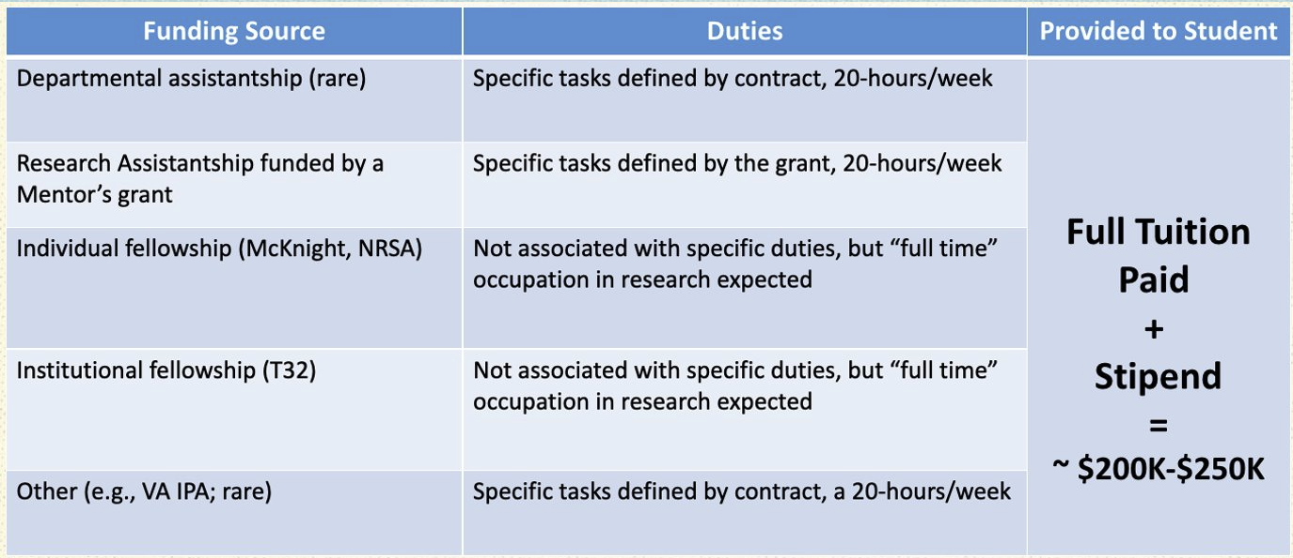***Funding Sources and Responsibilities***

***Graduate Assistantships and Fellowship Required Credits***

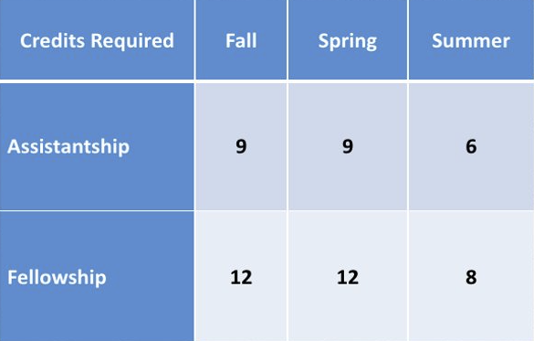

***Fees***. Students may be responsible for fees associated with some departmental courses (e.g., Child and Adult Assessment courses and certain practicum courses).

***Health Insurance***. [GatorGradCare](https://benefits.hr.ufl.edu/health/gatorgradcare/) health insurance is available exclusively to Graduate Assistants, Teaching Assistants, and Research Assistants on appointment (0.25 FTE or greater) at UF.

***Outside Employment***. To ensure that students receive high quality education and timely progress toward their degrees and to assure oversight that each student achieves competency in their clinical and scientific endeavors, any student receiving any funds from the University (i.e., grants, graduate assistantships) **must not accept** other employment of any kind without the written permission of the Mentor, Director of Clinical Training, and Director of Graduate Education. Students must complete the ***Request to Participate in Outside Employment*** form. CHP discourages students working for the faculty (even paid work) when the work is not professional in nature, except in extraordinary circumstances, or in situations when there is minimal risk of negative outcomes due to dual relationships.

***CHP Trainee Emergency Fund*.** Students may experience unexpected emergencies including house fires, payment errors resulting in an extended period without financial support, and unexpected illness of self or close others. The purpose of this fund is to provide emergency financial assistance to trainees that experience financial hardship as a result of such unexpected crises. To apply for these funds, please complete the ***CHP*** ***Trainee Emergency Fund Application*** form. Decisions about funds will be determined by the Chair or the Chair’s designee who then coordinates with the PHHP Director or Associate Director of Development to facilitate release of funds to the trainee. Students are not required to repay funds distributed from the CHP Trainee Emergency Fund.

**MILESTONES & COMMITTEES**

## *Graduate Advisement & Supervisory Committees.* Using the [Graduate Student Handbook](http://graduateschool.ufl.edu/media/graduate-school/pdf-files/handbook.pdf), students should be familiar with the supervisory committee (i.e., Master’s and Doctoral Committees) appointment process and eligibility for membership prior to forming a committee.

***Types of Committees.*** There are two committees, a Master’s Thesis Committee and Doctoral Committee. Prior to registration for an upcoming semester, students should seek academic advisement from their Committee Chair (Mentor) and other appropriate faculty.

1. A student’s Mentor will typically be the Chair of both committees.

2. The committee members for the Master’s Thesis Committee and Doctoral Committee can be the same, but this is not always the case.

3. The Doctoral Committee oversees the Qualifying Examination, Dissertation Proposal, and Dissertation Defense.

4. See the [Graduate Student Handbook](http://graduateschool.ufl.edu/media/graduate-school/pdf-files/handbook.pdf) about making changes to committee members.

***Duties of the Master’s Thesis and Doctoral Committees***

1. Inform the student of all regulations governing the degree sought (this does not absolve the student from the responsibility of becoming informed of the regulations).

2. Meet, discuss and approve a topic and make plans to complete the research.

3. Evaluate in writing, on an annual basis, the student's research progress.

***Process for Forming Committees***. Although students work with their Mentor to form their Master’s Thesis and Doctoral Committees, the Committees are formally nominated by the department, and appointed by the Dean of the Graduate School, who is an ex officio member of all committees.

***Documents Required for Forming Committees*.** All documents for forming the Master’s Thesis and Doctoral Committees require signatures of all committee members. Once signatures are obtained, the Academic Coordinator posts the information to the Graduate Information Management System (GIMS) which is an extension of your Graduate School record.

***Special Appointment of a Committee Member.*** The [Graduate Student Handbook](http://graduateschool.ufl.edu/media/graduate-school/pdf-files/handbook.pdf) outlines the Special Appointment process in which under special circumstances, a student may request that a faculty member who does not have Graduate Faculty status be given a “special appointment” to a committee, subject to certain restrictions. Before you start this process, you will need:

1. The faculty member’s UFID.
2. The faculty member’s most up-to-date curriculum vitae.
3. An evaluative statement from the faculty member’s Chair or Director explaining the knowledge, experience and skills this special appointment will bring to the student’s research as a guest expert on his/her supervisory committee.

***Physical Presence Expectations at Milestone Meetings.*** We adhere to the [Physical Presence policy of the University of Florida Graduate School](http://graduateschool.ufl.edu/media/graduate-school/pdf-files/physical-presence-policy.pdf). The policy is flexible with regard to in-person versus online meetings, but requires the department to have a consistent policy. The CHP policy is:

1. Milestone meetings in which the student and their Committee are physically present in the same room are preferred; they foster social connection, casual exchanges, and collaboration.

2. A student and their Committee may opt for a fully online meeting (e.g., Zoom, Microsoft Teams), or a hybrid meeting (i.e., most participants are physically present in the same room, but one or more members has to participate remotely) as needed. Fully online meetings are preferred to hybrid meetings, due to the sensory challenges of meetings conducted in rooms where each person does not have an individual microphone and camera.

3. Under all circumstances, meetings must be live and all members participating at the same time.

4. The dissertation defense is a *public* defense, and will be announced to CHP by the Doctoral Program office. This requires that the modality of participation be determined in advance, so that the physical or virtual meeting location can be announced..

5. A public defense consists of:

a. Candidate presentation, which may be interrupted by questions;

b. Public members may ask questions, but then will be asked to leave;

c. Members of the Doctoral Committee will then ask any remaining formal examination questions;

d. Candidate will be asked to temporarily leave the room, and a pass/fail vote will occur among Committee members; and

e. Candidate will be asked to return to the room to receive their final grade and any feedback.

***Am I Permitted to Bring Food and/or Beverages to Proposal or Defense Meetings?*** Students are not allowed to bring food or beverages for their Committee members during the oral Master’s Thesis defense, Qualifying Examination, or Dissertation proposal/defense meetings. In conjunction with this policy, faculty are not allowed to ask students to bring food or beverages to these meetings.

### **FIRST YEAR PROJECT & MASTER’S THESIS**

### ***Overview of the First Year Project and Master’s Thesis*.** The goal of the First Year Project is to provide the student with a mentored research experience that promotes competency in the conduct of empirical research. The First Year Project is required of all students entering with a Bachelor’s degree or a Master’s degree in which a thesis was not completed. The First Year Project culminates in the Master’s Thesis Proposal, which is presented to CHP at the Annual Fall Symposium in November. The student then completes the written thesis document that is orally defended to the Master’s Thesis Committee, which should be a well-developed research manuscript suitable for publication in a peer-reviewed scientific journal. However, the written document must be formatted consistent with the requirements of the [UF Graduate School Editorial Office](http://graduateschool.ufl.edu/about-us/offices/editorial/).

|  |  |
| --- | --- |
| **Master’s Thesis Committee Members** | |
| ***Committee Chair*** | This should be your Mentor. This member must have graduate faculty status. |
| ***Internal Area Committee Member or Co-Chair*** | Must be a CHP faculty member and is in your Area of Concentration. Prior to registration for an upcoming semester, students should seek academic advisement from their Committee Chair (mentor) and other appropriate faculty. |
| ***External Committee Member*** | Must be a CHP faculty member but not in your Area of Concentration OR a faculty member who is not in CHP. This member must have graduate faculty status. |
| ***What if I want to Include a Member on My Committee Who Does Not Have Graduate Faculty Status?*** | See section **Special Appointment.** |
| ***What if I want to Change a Member of my Master’s Thesis Committee?*** | The composition of the Master’s Committee may be changed with an appropriate rationale, but ***the Graduate School will not accept committee changes during the semester in which the student receives a degree.*** The student should collaborate with the Mentor to identify a new member, communicate with both the former and new member, and complete the ***Change in Committee Member Form***, which only needs to be signed by the Chair of the Doctoral Committee (Mentor) and the new Committee Member. |

***Documentation Needed to Finalize the Master’s Thesis Committee.*** The student must complete the ***Master’s Thesis Committee Formation Approval & Signature Form*** for the Academic Coordinator to enter the names of the Master’s Thesis Committee members into GIMS. ***If this form is not submitted, the committee will NOT be recorded in the Graduate School system.***

***Deadlines***. All [deadlines](http://graduateschool.ufl.edu/about-us/offices/editorial/editorial-deadlines/) for Thesis Submission for the UF Graduate School are strictly enforced.

***What Happens After You Successfully Defend?*** The Academic Coordinator will enter your defense date into the Student Information System (SIS) and it will be recorded with the Graduate School.

1. If this is not competed by the [deadline](http://graduateschool.ufl.edu/about-us/offices/editorial/editorial-deadlines/), the student will **NOT** graduate with their Master of Science degree in the Spring of the 2nd year.

2. This [deadline](http://graduateschool.ufl.edu/about-us/offices/editorial/editorial-deadlines/) is the last day to upload your fully formatted thesis to GIMS as well as the last day for the Academic Coordinator to submit your signed defense form to GIMS.

3. If both steps are not complete, your Master’s Thesis submission will not be accepted by the Graduate School and you will not be able to graduate in Spring. The **Final Submission** deadline will be at the beginning of **April and is determined by the Graduate School**.

4. Students must formally apply to graduate with their Master of Science at the end of Spring semester of the 2nd Year. **Note: The** [**degree application**](http://graduateschool.ufl.edu/graduate-life/graduation/degree-applications/) **MUST be completed by the student in ONE.UF by the deadline set by the Registrar each semester.**

**FIRST YEAR PROJECT AND MASTER’S THESIS TIMELINE**

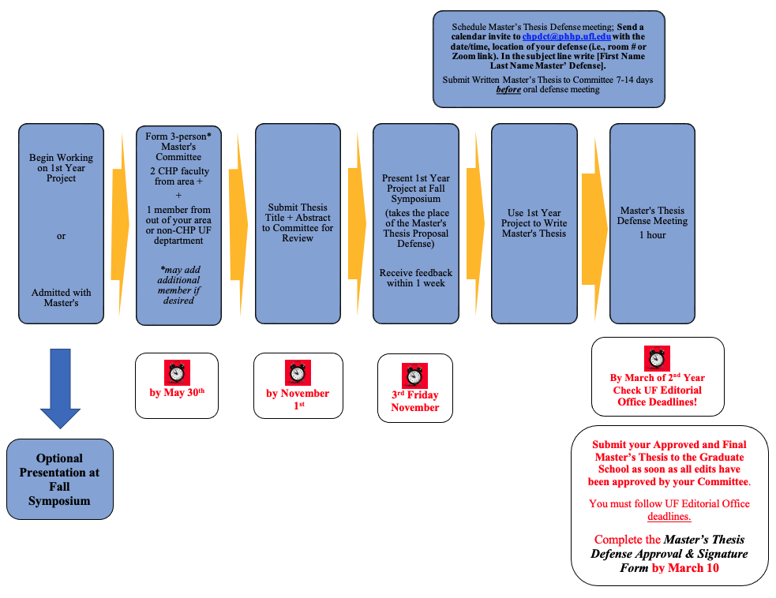

**What Happens if I Defend My Master’s Thesis After March of My 2nd Year?**

***The student MUST***

1. Inform the Academic Coordinator that they will be on a delayed timeline.

2. Continue to register for CLP 6971 until the semester in which the Master’s Thesis is defended and submitted to the Graduate School; and

3. Follow the deadlines for these processes in accordance with the Graduate School immediately following completion of the defense. This is VERY important to ensure that the student’s timeline is on track.

## *What if I Completed a Master’s Thesis Prior to Admission to the University of Florida?* Students who enter the program with a Master’s degree in which a thesis was completed should submit their thesis document to the Program Office by September 1. A committee led by the Director of Graduate Education will determine if the thesis meets CHP research standards.

### 1. All master’s degrees must be earned in the last 7 years.

2. If the Master’s Thesis ***meets*** the Department’s standards it becomes an *approved* Master’s Thesis.

a. Students are be encouraged, but not required, to complete a First Year Project that will not lead to a thesis. Instead, the project can be used to support manuscript development.

b. Form Doctoral Committee after completing 12 credit hours or at the end of the 2nd semester as required by the Graduate School. See **Doctoral Committee** section.

3. If the Master’s Thesis ***does not meet*** the Department’s standards

a. The student is required to develop a new project with their Mentor.

b. Present at Fall Symposium.

c. Defend to a Master’s Committee.

d. Submit the Master’s Thesis to UF’s Editorial Office.

e. Receive a Master’s of Science in Clinical Psychology from UF.

# ESTABLISHING THE DOCTORAL COMMITTEE

### ***Doctoral Committee.*** Advisement for each student is assumed by the Mentor who typically serves as the Chair of the Doctoral Committee. This person likely chaired the student’s Master’s Thesis Committee. The Doctoral Committee comprises a minimum of 4 members. Often, members of the Master’s Thesis Committee serve as members of the Doctoral Committee, with one additional external member. **The Doctoral Committee should be appointed by the end of the 6th semester, which is the Summer of the 2nd year.**

***Doctoral Committee Requirements.*** At least 2 committee members must be tenure-track faculty within CHP (i.e., faculty with a primary Clinical appointment are not tenure-track). If the recommended Chair of the Doctoral Committee is not a member of CHP tenure-track faculty, then a co-chair is selected from the CHP tenure-track faculty who takes responsibility for CHP program requirements and regulations associated with the Doctoral Qualifying Examination and Doctoral Dissertation.

|  |  |
| --- | --- |
| **Doctoral Committee Members** | |
| ***Doctoral Committee Chair*** | Chair should be your Mentor in your Area of Concentration. Must have Graduate Faculty Status in the Department of Clinical and Health Psychology |
| ***Internal Area Committee Member or Co-Chair*** | Must be a faculty member that is in CHP and is in your Area of Concentration. |
| ***External Committee Member*** | This member must be external to our department (i.e., cannot be a member of the CHP Graduate Faculty (even if their primary Graduate Faculty appointment is with another program or unit). |
| ***What if I Want to Include a Member on My Committee Who Does Not Have Graduate Faculty Status?*** | See section **Special Appointment.** |
| ***What if I Want >4 Members on my Doctoral Committee?*** | At the discretion of the student and Doctoral Committee Chair, the committee may consist of >4 members. |
| ***What if I Want to Change a Member of my Doctoral Committee?*** | The composition of the Doctoral Committee may be changed with an appropriate rationale, but ***the Graduate School will not accept committee changes during the semester in which the student receives a degree.*** The student should collaborate with the Mentor to identify a new member, communicate with both the former and new member, and complete the ***Change in Committee Member Form***. The form only needs to be signed by the Chair of the Doctoral Committee and the new Committee Member. |

***Documentation Needed to Finalize the Doctoral Committee*.** The student must complete the ***Doctoral Committee Formation Approval & Signature Form*** for the Academic Coordinator to enter the names of the Doctoral Committee members into GIMS. ***If this form is not submitted, the committee will NOT be recorded with the Graduate School.***

## DOCTORAL QUALIFYING EXAMINATION TIMELINE & GUIDELINES

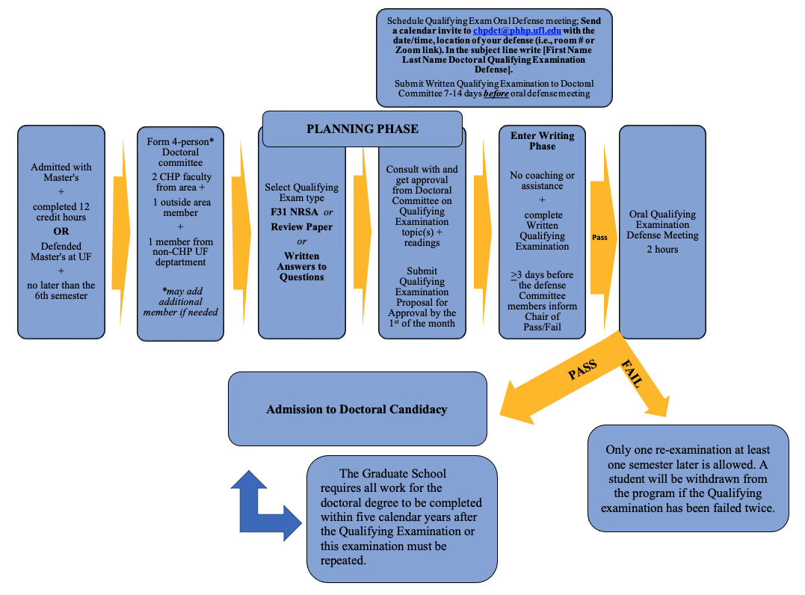

## *Overview of the Doctoral Qualifying Examination*. The Qualifying Examination consists of a written and oral examination. It is an independent and original project that is conducted by the student with the approval and ongoing consultation of the Doctoral Committee. It is tailored to mastery of content in which the student wishes to gain special expertise A previously prepared grant proposal or review paper is not allowable to satisfy the Doctoral Qualifying Examination requirement. Ultimately, the Doctoral Qualifying Examination fosters the student's integration of information from didactic coursework, practical experience, and personal research on advanced topics of contemporary importance to clinical and health psychology.

***University of Florida Graduate School Requirements***. The Qualifying Examination must: 1) contain both a written and an oral exam; and 2) cover Clinical Psychology and Area of Concentration topics.

***Administration of the Doctoral Qualifying Examination***: 1) Evaluates the student's mastery of content areas that form the scientific and applied foundations of professional psychology; and 2) provides an opportunity for students to demonstrate competence in those special areas of expertise they individually identify as important to their development as professional psychologists.

***How Long is the Oral Exam Associated with the Doctoral Qualifying Examination?*** The exam must be scheduled for 2-hours.

***Required Timeline Between Oral Defense of Qualifying Exam and Date of Degree***. At least 2 semesters must occur between the oral defense and date of degree. The semester the Qualifying Examination is passed is counted, if the examination occurs before the midpoint of the term.

***What if I Need to Remediate My Written Doctoral Qualifying Examination?*** Students may reschedule their defense at a time approved by their Committee: 1) a minimum 2 month wait before resubmitting is suggested, to give the student adequate time to revise carefully; and 2) it is recommended that no more than 1-2 semesters pass before rescheduling.

1. If, after the written Doctoral Qualifying Examination is graded, the student has not obtained a majority of pass grades, the student will have one final opportunity to rewrite the Qualifying Exam.

a. For systematic reviews and NRSAs, students will submit a revised draft that addresses Committee concerns.

b. For written answers to questions

i. If a student fails only one topic, only that topic needs to be rewritten.

ii. If a student fails two topics, the Committee will determine whether only the failed topics, or all three topics, need to be rewritten.

2. Committee members are permitted to provide feedback to the student before they begin rewriting.

a. The committee can keep their previously scheduled committee meeting, and share feedback as a group, or

b. The student can meet individually with each Committee member and compile feedback, or

c. Committee members can relay feedback through the Chair of the Committee.

3. Feedback should take the form of detailing

a. What led to failing, and

b. What needs to be improved in a future draft.

4. Feedback can also include additional references/readings.

***Documentation Needed to Finalize the Doctoral Qualifying Examination****.* The student must complete the ***Doctoral Qualifying Examination Oral Defense & Signature Form*** for the Academic Coordinator to enter the information into GIMS. ***If this form is not submitted, the committee will NOT be recorded with the Graduate School.***

| **PLANNING PHASE with MENTOR** | | | |
| --- | --- | --- | --- |
|  | **F31 NRSA Grant Proposal** | **Review Paper** | **Written Answers to Questions** |
| **Preparation** | * Plan the proposal * Establish specific aims and hypotheses | * Evaluate state of literature * Assemble relevant references | * Select 3 content areas * Each area must be sufficiently different and extensive to provide breadth of coverage * 2 content areas specific to the Area of Concentration and dissertation topic * 1 content area general clinical psychology not related to student’s specific research area and not related to the same treatment modality or health condition in the other 2 questions * Develop reading lists or other study material |
| **Proposal Guidelines and Approval Criteria** | * 2 pages, Arial 11 point font * Page 1: Specific Aims describes specific research questions. * Page 2: 1-2 paragraphs briefly describing the methods planned to address the aims. * Include planned submission date, but submission is not required. * Follows [NIH SF424](https://grants.nih.gov/grants/how-to-apply-application-guide.html) format * Must be approved by the doctoral Committee | * 2 pages, Arial 11 point font * Include statement of purpose and goals * Address target problem or literature area * Adequately describe methods to selecting articles and other materials * Demonstrate appreciation for key issues in the topic of the review * Highlight anticipated outcomes that reasonably justify the work * Include planned submission date | * 2 pages, Arial 11 point font * 1 summary paragraph for each content area followed by reading list for each content area * Must be approved by Doctoral Committee * Include planned date for the written exam * Reading list developed by student and Committee Chair, with other Committee members’ input * Length of reading list cannot be mandated * Include only the citation for references (not the abstract) * Student likely reads additional, related material |

|  |  |  |  |
| --- | --- | --- | --- |
| **WRITING PHASE (Written portion of exam)** | | | |
|  | **F31 NRSA Grant Proposal** | **Review Paper** | **Written Answers to Questions** |
| **Collaboration** | * None | * None * May train 2nd rater to code articles following PROSPERO guidelines | * None * Permitted to solicit mock questions and feedback (ideally from trainee colleagues), but the Committee must not be involved |
| **Exam Logistics and Timeline** | * Anywhere at students’ discretion * Typically 6-9 weeks | * Anywhere at student’s discretion * Typically 6-9 weeks | * Reserve “quals room” * Typically 6-9 weeks * Begin at 8:30 AM * End at 4:30 PM * Plan for 1 hour per question * Remaining time can be used for breaks and review/editing of answers. * Computer provided * No internet, notes, books, devices, etc. |

|  |  |  |
| --- | --- | --- |
| **FORMAT GUIDELINES – FINAL WRITTEN EXAM** | | |
| **F31 NRSA Grant Proposal** | **Review Paper** | **Written Answers to Questions** |
| * Follow all SF424 (R&R) Individual Fellowship Application guidelines and requirements * The final proposal must contain: * Abstract * Project Summary * Narrative * Specific Aims * Research Strategy * Human Subjects and Clinical Trials Information * Inclusion of Women and Minorities * Inclusion of Individuals Across the Lifespan * Responsible Conduct of Research * Applicant’s Background and Goals for Fellowship Training * Biosketch (student only) * References * Planned submission date | * Type of Review Paper may be: * Narrative * Systematic * Scoping * Meta-analysis * Must be Arial 11 point font * 35-50 double spaced pages not including references * 1-inch margins * Does not include references, tables, figures * The internal format of the review is decided upon by the student in consultation with the Doctoral Committee. * The final document submitted by the student should be in APA format or if a journal is selected, in that journal’s format. * Planned submission date | * 6 questions total; 2 in each content area * A copy of the list of references (citations only) is allowable * The examination questions are not limited by the content from the reading list, but the content of the reading list and the scope of the examination questions should be comparable * Written examination is prepared by the Committee. * Chair of Committee oversees its preparation, soliciting questions and input from the Committee |

|  |  |  |
| --- | --- | --- |
| **DISTRIBUTION OF WRITTEN EXAM** | | |
| * Email to Committee Chair by due date * Chair distributes exam and grading forms to Committee | * Email to Committee Chair by due date * Chair distributes exam and grading forms to Committee | * Provide exam answers on a flash drive to Academic Coordinator * Academic Coordinator emails exam to committee Chair by 5:00 PM * Chair distributes exam and grading forms to Committee |
| **GRADING OF WRITTEN EXAM** | | |
| **For all exam types: *Chair must communicate pass/fail feedback to the student within 3 calendar days before the scheduled oral examination*** | | |
| * Each Committee Member assigns an outcome: * Approved * Approved with Revisions * Revise and Resubmit * Not Approved * Assign a Priority Score; 1-9 with 1 = best * Approved from 3/4 or 3/5 of Committee members is required | * Each Committee Member assigns an outcome: * Approved * Approved with Revisions * Revise and Resubmit * Not Approved * Approved from 3/4 or 3/5 of Committee members is required | * Based on answers to 2 questions in each content area, each Committee member assigns an outcome to each topic area as a whole. * Approved * Approved with Revisions * Revise and Resubmit * Not Approved * Approved from 3/4 or 3/5 of Committee members is required on all three topics |
| **IF WRITTEN EXAM IS NOT PASSED** | | |
| * Committee offers student 1 additional opportunity to rewrite the exam * Topic or format changes may be submitted to the graduate faculty for approval * There is only 1 opportunity to rewrite the exam. * If the 2nd attempt is not approved, student is dismissed and does not enter candidacy | * Committee offers student 1 additional opportunity to rewrite the exam * Topic or format changes may be submitted to the graduate faculty for approval * There is only 1 opportunity to rewrite the exam. * If the 2nd attempt is not approved, student is dismissed and does not enter candidacy | * If student does not pass only 1 area, only that area needs to be rewritten * If student does not pass 2 areas, Committee decides whether only the not-passed areas need to be rewritten, or whether the entire exam must be rewritten. * There is only 1 opportunity to rewrite the required portions of the exam. * If the 2nd attempt is not approved, student is dismissed and does not enter candidacy |
| **Breadth of oral examination** | | |
| * 2-hours scheduled with the Committee * Oral examination should include content relevant to the broader field of Clinical Psychology, as required by Graduate School policy. | * 2-hours scheduled with the Committee * Oral examination should include content relevant to the broader field of Clinical Psychology, as required by Graduate School policy. | * 2-hours scheduled with the Committee * < 5 type-written pages of notes, reflecting the student’s evaluation of and self-assessment of their written qualifying exam performance * May not include any information resulting from discussions with any person about the student’s written exam. * Copy of notes will be provided to Committee Chair before beginning the oral exam. |

## DISSERTATION PROCESS

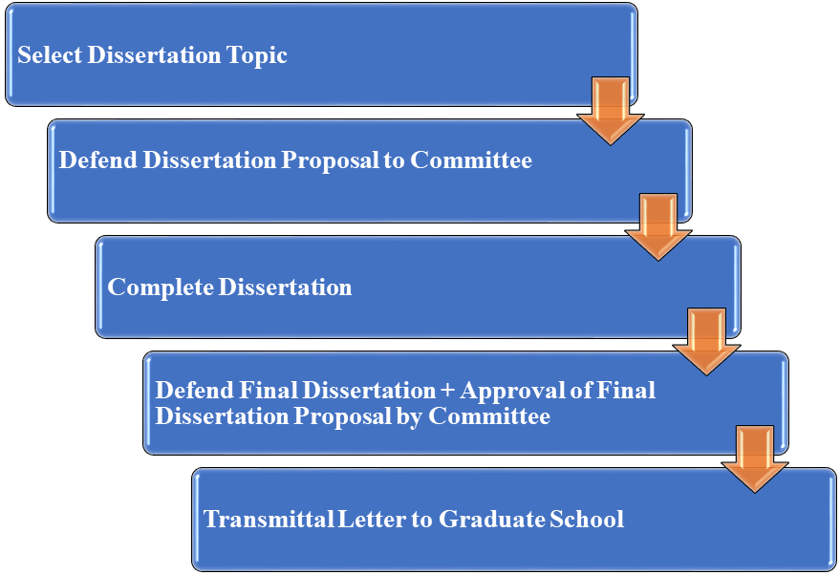

Follow the same administrative procedures (e.g., scheduling, completion of required documentation, deadlines) as outlined in the Master’s Thesis and Doctoral Qualifying Examination descriptions.

**DISSERTATION PROPOSAL AND DEFENSE MEETINGS**

***Is the Dissertation Proposal a Formal Graduate School Milestone?*** Unlike the Qualifying Examination Defense and Dissertation Defense, it is not a formal milestone.

***Purpose of Dissertation Proposal Meeting***. To obtain Committee approval prior to commencing the dissertation.

***Requirements of the*** ***Dissertation Proposal.*** Students will provide a written document comprised of Specific Aims/Research Questions, Background/Significance, and Methods) to their committee >7 days before the proposal meeting.

1. ***Introduction***: covers the relevant literature in the subject area, with a full and balanced critique, a clear definition of the problem, and a defense of the relevance of the problem;

2. ***Methods***: contain all requirements from the ***APA Publication Manual*** for methods, as well as detailed description and defense of all measures to be used; a detailed proposal of all statistical analyses to be performed (including the analyses of descriptive statistics, defense of the number of variables per subject and power estimates if appropriate); and all analyses to test each hypothesis.

3. ***References***.

***What Happens During the Dissertation Proposal Meeting?***

1. **The meeting must be scheduled for 2-hours.** Students will conduct an oral presentation of their proposal, and respond to Committee questions and feedback.

2. At the end of the meeting, the Committee must vote whether the student’s dissertation proposal is approved. Four possible outcomes are possible:

a. **Proposal Approved** (50% + 1 of the Committee vote to Approve). The student obtains Committee members’ signatures on the ***Doctoral Dissertation Proposal Approval & Signature Form***.

b. **Proposal Approved with Revisions**. The committee may choose to: 1) let the mentor affirm that revisions have been made; 2) ask that a revised proposal be sent to them; or 3) request another meeting.

i. Only when the committee members indicate that the proposal is Approved (50% + 1 of the committee vote to approve) should the student obtains committee members’ signatures on the ***Doctoral Dissertation Proposal Approval & Signature Form***.

c. **Proposal to be Revised and Resubmitted**. If substantial revisions or corrections are requested, the Committee should schedule a subsequent proposal meeting.

i. Only when the Committee members indicate that the proposal is approved (50% + 1 of the Committee vote to Approve) should the student obtains Committee members’ signatures on the ***Doctoral Dissertation Proposal Approval & Signature Form***.

d. **Proposal Not Approved**. Occurs when the majority of the Committee (50% + 1 of the Committee vote as Not Approved) determines that the proposed research is fatally flawed, and cannot be made acceptable, even with extensive revision.

i. Development of a new proposal is required.

ii. No signatures are obtained.

***Dissertation Defense***. The final doctoral dissertation includes the Introduction, Methods, Results, Discussion, and References.

**OVERVIEW OF COURSE REQUIREMENTS RELATED TO COMPETENCIES IN DISCIPLINE-SPECIFIC KNOWLEDGE and PROFESSION-WIDE COMPETENCIES**

# *Area of Concentration Courses*. Area of Concentration courses taken are based on individual interests and the number of credits required vary. They are based on several factors including, but not limited to student’s financial assignment (Assistantship, Fellowship), the nature of selected Area of Concentration, and electives.

# *Required Courses*. Required courses are offered in accordance with the American Psychological Association’s Commission on Accreditation Implementing Regulations for Doctoral Graduate Programs. Courses are expected to meet Standard II.B.1.a: Discipline-Specific Knowledge and Profession-Wide Competencies serve as a cornerstone of identity as a psychologist and orientation to health service psychology.

The [Course Schedule](https://chp.phhp.ufl.edu/current-students/course-schedules/) for each semester is published as far in advance as possible. In addition, the [CHP website](https://chp.phhp.ufl.edu/current-students/course-schedules/) contains specific information about Area of Concentration requirements and suggested timelines for course completion based on Area of Concentration.

***CLP 6905 (Individual Work/ Directed Individual Study*)**. This course can be taken at any time and is graded (i.e., not S/U). Request enrollment by completing the ***Directed Individual Study*** ***Form***. This course is not to be used for preliminary work on the doctoral dissertation.

***The*** [***CHP 5-Year Teaching Plan***](https://chp.phhp.ufl.edu/current-students/course-schedules/) aids students with planning their time and schedules.

***Total Credit Hours Required for the Ph.D***. The Graduate School requires > 90 credits.

***Retain Copies of Syllabi***. Licensing boards enforce core foundational education strictly. Retain copies of all graduate transcripts and syllabi for documentation when applying for licensure.

***Didactic Training.*** Independent study courses taught by faculty outside of CHP must be approved by the Mentor, Area Faculty, and Associate Chair of Graduate Education.

***Public Health Courses***. All CHP students are required to take PHC 6001 Principles of Epidemiology and Introduction to Public Health.

***Putting Families First***. All 1st year students participate in [Putting Families First](https://education.health.ufl.edu/courses/pff/) that is managed by the UF Health Office of Interprofessional Education.

***What if I Took Courses Prior to Being Admitted to UF?*** Students who took graduate level courses and earned a minimum of a B- may request to waive a required class(es) by completing the ***Documentation of Course Waiver or Substitution Form***. The UF Faculty member who teaches the comparable course determines if the syllabus of the course to be waived meets the UF requirement and provides approval. Other course materials (e.g., papers, examinations) may be requested. The UF Faculty member may deny the request or recommend conditional approval based on the student’s completion of additional requirements. If conditionally approved, the faculty member may recommend that the student attend lectures to supplement their education, or may recommend completion of an additional requirement. A separate form petitioning the Graduate School for transfer of credits from the student’s prior institution is not required or necessary, unless the student wants to use these credits toward meeting graduation requirements. The student should consult the Academic Coordinator for instructions on how to obtain Transfer of Credit forms.

**History and Systems of Psychology**. The only undergraduate course that may be substituted for a required Discipline-Specific Knowledge course is a History and Systems of Psychology course. It is highly recommended that if a course was taken for undergraduate credit and at least a B- was earned in the course, then complete the ***Documentation of Course Waiver or Substitution Form***.

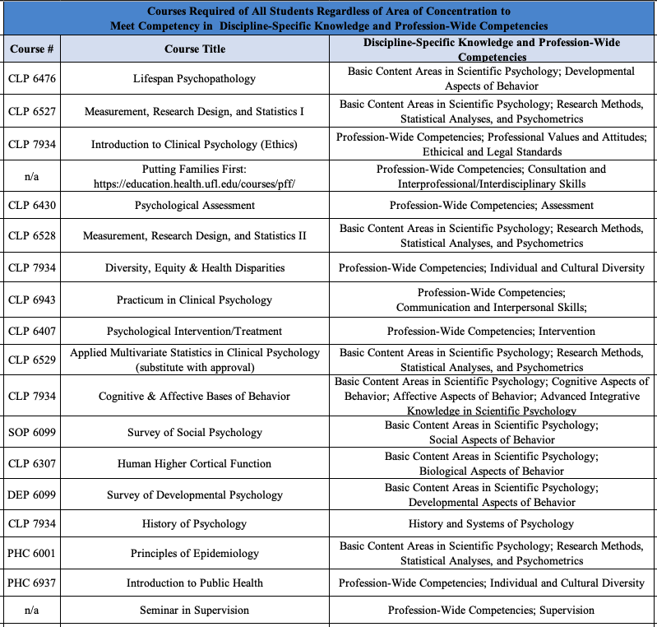

**RESEARCH**

All research activities (thesis and dissertation) conducted to meet the requirements of the doctoral training program must be supervised by CHP faculty or those UF faculty holding a joint appointment with CHP. Exceptions require approval of the Area Faculty and Associate Chair of Graduate Education and appointment of a CHP faculty member as the Committee Co-chair.

## *Research Mentorship Policy*. This policy sets forth requirements for faculty assignment to research mentorship roles within CHP. It is designed to assure that students receive effective and high-quality research mentorship. This policy supplements roles and responsibilities of Graduate Faculty as set forth by the Graduate School and describes CHP operating principles.

1. ***Membership on the Graduate Faculty***. All CHP faculty are eligible to apply for appointment to the Graduate Faculty. The Chair prepares the nomination, which is reviewed and voted upon by CHP Graduate Faculty.
2. ***Membership on Doctoral and Master’s Committees***. Graduate Faculty status affords the opportunity and responsibility to serve on Master’s and Doctoral Committees within the Department. Appointment to specific committees is subject to approval by the research Mentor, Director of Graduate Education, and Department Chair.
3. ***Chairing Doctoral and Master’s Committees***. Serving as Chair of a Doctoral or Master’s committee is a responsibility reserved for Graduate Faculty members on the tenure-track. This responsibility aligns with the substantial assignment to research by these faculty.
   1. ***Tenured*** faculty members and associate professors on the tenure-track may chair committees.
   2. ***Assistant professors on the tenure-track*** may supervise Doctoral or Master’s research by serving as Chair along with a tenured faculty member, who serves as official Co-Chair. This requirement is applicable until:
      1. The faculty member graduates one student with a Master’s degree from UF (they may then supervise future Master’s students without a co-Chair) and/or one Doctoral student (they may then supervise future Doctoral candidates without a co-Chair), or
      2. achieves tenured status, whichever comes first.
      3. At this point, subsequent Master’s and Doctoral committees chaired by this faculty member do not require a Co-Chair.
      4. An exception to the rule that tenure-track assistant professors must have graduated one Master’s and Doctoral candidate first may be made in special circumstances, which will be reviewed and, if appropriate, approved by the Director of Graduate Education and the Department Chair.
4. ***Non-tenure-track faculty*** (faculty on Clinical or Research tracks, or Graduate Faculty with primary appointments in other departments) may not, except in special circumstances, supervise Master’s and Doctoral work unless reviewed and, if appropriate, approved by the Associate Chair of Graduate Education and Department Chair. If approved, the non-tenure-track faculty member may assume Co-Chair responsibilities along with a tenured faculty member or a tenure-track faculty member who has met the requirements to be Chair, who will serve as the official Chair.
5. ***Student Admission to Research Mentors***. Upon admission, students will be assigned to work with a research mentor who is a member of the tenure-track faculty.

***Outside Research Activities***. All research activities outside of the thesis and dissertation project requirements that are not conducted under the supervision of a CHP faculty member or UF faculty member with an appointment in CHP must be approved by the Area Faculty, Chair of the student’s Master’s and Doctoral committee, Director of Clinical Training and Director of Graduate Education. Complete the ***Request to Participate in Research/Clinical Activity Outside the Department Form***.

***Counting Research Hours Toward Internship Hours.*** Students who have face-to-face hours performing clinically relevant activities with patients can count those hours as direct clinical hours if the following conditions are met:

1. The student meets regularly with the research supervisor (“regularly” can be defined uniquely, but there should be a standing, routinely scheduled means for obtaining supervision from the PI/mentor).

2. The supervision has a mechanism whereby the student’s clinically relevant activities are routinely reviewed (e.g., this may be a discussion about the week’s intervention or assessment accomplishments, the patients enrolled)

3. The supervision must allow students the opportunity to discuss enrolled participants at an individual level (this does NOT mean that every enrollee must be discussed or reviewed explicitly; there just needs to be an opportunity to do so if needed).

The research supervisor DOES NOT need to be licensed to perform clinical service activities, but should have demonstrated competencies in the activity that is supervised. Clinically relevant activities that qualify for direct contact or face-to-face hours should be reasonably connected to the subject matter for which the hours are being counted. For example, it is defensible to count face-to-face hours spent in active intervention or assessment of behavior, cognition, functional adaptation, etc. than it is to count hours collecting and spinning blood samples or segmenting hippocampi on MRI scans because the former is more central to the definition of the kinds of activities that health service psychologists conduct. **The simple administration of questionnaires does not count as hours.**

# PRACTICUM REQUIREMENTS & CLINICAL COMPETENCIES

***Overview***. The clinical practicum sequence is designed to develop a range of clinical skills and competencies in health service psychology under close supervision of a licensed psychologist. The Director of Clinical Training and Area Heads assign students to their practicum. The areas in which the program strives for the development of basic competencies are consistent with recommendations made by [APA](https://www.apa.org/ed/graduate/competency.html).

***Practicum Schedules*** are posted as far in advance as possible.

***Practicum Length****.* Each practicum is expected to be completed for the entire semester; however, exceptions may be granted with the approval of the supervisor and the Director of Clinical Training. The UF Health Psychology Specialties Clinic only closes on UF Holidays, when UF Health closes (e.g., in the event of a hurricane), and December 25 to January 1 (or the corresponding observed holiday) when the entire UF campus closes for the winter holiday break. ***Students are not permitted to see patients when the clinic is officially closed (e.g., when the clinic is closed because of a hurricane) and should never be expected to see patients either through video or in-person.*** In addition, we follow [UF policy](https://catalog.ufl.edu/UGRD/academic-regulations/attendance-policies/#religiousholidaystext) that allows students to observe the holy days of their faith.

Please always consult the official [UF Academic Calendar](https://catalog.ufl.edu/UGRD/dates-deadlines/) to determine the date that classes begin each semester. Please note that practicum dates do not coincide with the actual length of the UF defined semester. Rotations typical begin and end:

**Fall Semester**

1. Fall Begins: The Monday of the 3rd week in August. Note that practicum begins before classes begin, which is typically the Wednesday of the Fall semester.

2. Fall Ends: The day before Christmas Eve (or the Friday before if Christmas falls on the weekend). Not that the end date does not coincide with the end of the semester.

**Spring Semester**

1. Spring Begins: The Monday of 1st week of January, which is typically the week before spring semester classes begin.

2. Spring Ends: The Friday of the 2nd week in May. Note that the end date does not coincide with the end of the semester.

**Summer Semester**

1. Summer Begins: The Monday of the 3rd week in May, which is typically the same week as the beginning of summer classes.

2. Spring Ends: The Friday of the 3rd week in August. Note that the end date does not coincide with the end of the semester.

***Supervision.*** A faculty member with an appointment in CHP (e.g., courtesy, adjunct, joint) must provide direct, face-to-face supervision of all practicum experiences. Faculty members outside of CHP may also provide supervision if the practicum experience is approved by the Area and Director of Clinical Training, and if the faculty member agrees to participate in our formal practicum evaluation procedures.

***Practicums Outside of the UF Health Psychology Specialties Clinic***. The Core Assessment Practicum and the Advanced Practicum required by the student’s Area of Concentration (CLP 6945, Advanced Practicum in Neuropsychology; CLP 6946, Advanced Practicum in Applied Medical Psychology; CLP 6948, Advanced Practicum in Clinical Child Psychology) must be completed successfully *before* additional advanced practicum, supervised by a faculty member outside the department, may be arranged. Practicums arranged outside of CHP require approval from the: 1) student’s Mentor, 2) faculty in the student’s Area of Concentration; and 3) Director of Clinical Training. The ***Petition to Complete External Practicum Form*** must be completed.

***Clinical Hours Tracking*.** Tracking clinical hours is essential for the student’s application for internship which is managed through the [Association of Psychology Postdoctoral and Internship Centers (APPIC)](http://www.appic.org/). To assist students with managing their accumulation of clinical hours across time, all clinical activities must be entered into ***Clinical Data, Patient Demographics and Clinical Hours Tracking and Patient Logs***.

***How to Categorize Psychological Diagnostic Evaluations*** (i.e., intake interviews, CPT Code 90791). APPIC rules stipulate that if a psychological diagnostic evaluation leads to therapy, then the hours spent in that interview are categorized as intervention. If a psychological diagnostic evaluation leads to testing, then the hours spent in that interview are categorized as assessment.

***Evaluations of Students in the Competencies in Professional Psychology***. At the end of each practicum, clinical supervisors complete the ***Competencies in Professional Psychology Evaluation Form*** to evaluate students on competency benchmarks in domains of professional psychology consistent with [APA](https://www.apa.org/ed/graduate/competency.html) recommendations.

***Direct Observation of Students.*** APA stipulates that for each practicum completed, the direct supervisor must directly observe the student.

***Clinical Progress Committee***. Once each year, the Clinical Progress Committee will complete a full of review each student’s clinical progress across the entire time the student has been enrolled in the program. Special consideration will be given to monitoring the student’s successful completion of the basic clinical competencies. The ***Clinical Progress Committee*** makes recommendations to the faculty and the Director of Clinical Training about the student’s clinical strengths and weaknesses during the student’s yearly evaluation by the faculty. Satisfactory clinical progress for the semester will be determined by the consensus of the faculty.

***Unsatisfactory Progress Toward Clinical Competencies***. If a student demonstrates unsatisfactory progress, the student may be: 1) required to remediate problems; 2) placed on probation; or 3) dismissed from the program.

***Clinical Supervisor Evaluations*.** Clinical supervision provided by licensed psychologists is evaluated internally to improve CHP’s clinical supervision practices and for when faculty are being reviewed for tenure and/or promotion. Students are encouraged to complete these faculty evaluations at the end of each practicum, which are completely anonymous.

## *Training in Delivering Clinical Supervision*. Students are required to participate in training in the delivery of clinical supervision, at some point during their enrollment in the program, designed to provide an introduction and exposure to delivering clinical supervision.

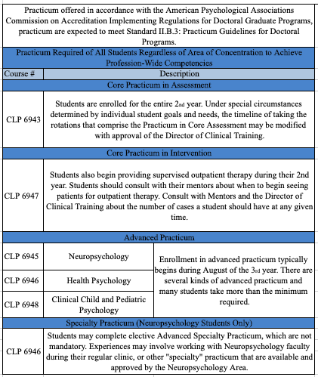

## CLINICAL Supervision

These policies pertain to all supervised patient contacts occurring in research and practicum settings. A major distinction is made between ***Direct Supervision*** (i.e., supervision provided directly by a licensed faculty member) and ***Indirect Supervision*** (i.e., supervision provided by an unlicensed trainee [e.g., post-doctoral associate] or faculty member who is, in turn, under the supervision of a licensed faculty member). When Indirect Supervision occurs, the student might not meet weekly with the licensed faculty member but receives most of the direct supervision from their unlicensed designee.

***Direct Supervision***. Direct Supervision is offered directly by licensed faculty members for services delivered physically in the local Academic Health Center environment, which is expected to be face-to-face and is governed by the existing UF Health Psychology Specialties Clinic Policy on Billing and Supervision. When licensed faculty supervise ongoing therapy cases, it is expected that the faculty will meet the patient directly during an initial therapy visit and that, during this meeting, the supervisory relationship between the faculty and student therapist will be discussed with the patient.

***Supervision Coverage***. When the supervisor is not officially at work at the Health Sciences Center or is out of town, a designated supervisor is the individual named as back-up supervisor, or in cases where this individual cannot be located, the UF Health Psychology Specialties Clinic Director. The faculty supervisor *de facto* transfers case responsibility to another physically present institutional representative (i.e., licensed psychologist) for supervision of patient care.

***Telesupervision.*** Supervision via video conference is permissible; however, supervisors and graduate students must ensure that they are located in a private room. **Supervision in public places is prohibited.**

***Supervision by Unlicensed Faculty and Post-Doctoral Associates***. Unlicensed faculty members and post-doctoral associates who provide supervision of students will follow all existing policies regarding billing and supervision. The licensed faculty member is ultimately responsible for these cases and should meet the patient during the assessment or an early therapy session, at which point the supervisory relationships are explained.

**Unlicensed faculty members** are required to establish regular supervision meetings with a licensed faculty supervisor. Unlicensed faculty are expected to pursue and obtain licensure at the earliest possible time they are eligible for licensure.

**Post-Doctoral Associates** are permitted to provide Indirect Supervision if an explicit policy for Direct Supervision is in place and students are advised of that policy, which includes an explicit plan about how to contact the licensed faculty supervisor directly for consultation. It is expected that the post-doctoral associate who provides supervision to students should have a regular supervisory meeting with the responsible licensed faculty member. Periodic (e.g., at least monthly) combined supervisory meetings involving the responsible faculty member, post-doctoral associate, and student should be arranged to allow for timely discussion of clinical and supervisory issues.

**Internship Requirement**

The internship, **which must be APA-accredited**, is a 1-year intensive supervised clinical experience that is the capstone of professional training in the Doctoral Program. While CHP offers its own APA-accredited internship, students typically apply to other APA-accredited sites to broaden their professional experience. The process is governed by agreements between Directors of Clinical Training and Internship Centers and is described by [APPIC](http://www.appic.org/).

***How Do I Know if I Can Apply for Internship?*** To apply for internship, the student must have made satisfactory clinical progress and have the approval of the Director of Clinical Training, the Clinical Progress Committee, and the Mentor/Doctoral Committee chair. To apply for internship, **the student must successfully defended the dissertation proposal by October 1** of the fall in which the internship application is made and must have a positive endorsement of the Clinical Progress Committee on file by that date. Students will be informed of the Clinical Progress Committee’s evaluation of their intern readiness as soon as it is completed.

***Preparing to Submit Internship Applications.*** The Director of Clinical Training holds a **required** Internship Preparation Seminar (not for credit) beginning in the summer semester for students planning to apply for internships the following fall semester.

***When to Apply***. Many students apply for internship in the fall semester of the 4th year.

***Where to Apply***. Choices of where to apply are made in consultation with the Mentor and the Director of Clinical Training.

***Can I Apply to an Internship that is Not APA-Accredited?* No.** Students are not permitted to apply to internships that are not accredited by the American Psychological Association.

***If I Do Not Match in Phase 1 or Phase 2, Can I Attend a Non-APA-Accredited Internship Through the Post-Match Vacancy Service Phase?*** **No**, all CHP students must complete an APA-Accredited Internship.

***Credit Requirements While Completing Internship***. A minimum of 6 credit hours (2 hours per each of 3 semesters) are required during the internship year of 12 months. Graduate School requirements for minimum enrollment during internship is 3 hours in fall semester, 3 hours in spring semester, and 2 hours in summer semester if you wish to be coded as full-time and receive financial aid.

**EVALUATION METHODS**

## *Program Evaluations*. Students provide feedback on the instructional quality of the program through course evaluations that are completed every semester. Students are strongly encouraged to write constructive and professional comments to give specific and detailed feedback. Instructional issues that arise during a course should be discussed with the course instructor, and, if appropriate, with the Program Directors. Individual students are encouraged to make recommendations or suggestions regarding program improvements or modifications through participation in the [Suggestion Box](https://ufl.qualtrics.com/jfe/form/SV_bwwoCtNjFL2upXn).

***Student Involvement***. Students contribute formally to program evaluation and enhancement. Students serve on the Curriculum Committee, the policy-making group for the program curriculum, and the Clinic Operations Group. Each class and each Area of Concentration has a student representative that meets with the Program Directors to address student concerns in a timely manner.

***Mentoring Meetings*.** Each student is expected to meet with their primary research Mentor on a regular basis and is encouraged to meet with the Director of Clinical Training and/or Director of Graduate Education as needed for the purpose of program review and an evaluation of personal progress.

## *Faculty Evaluations of Students*. The student's progress in the program and their promise as a clinical psychologist are evaluated continuously by the faculty. While feedback is provided on a continuous basis in the context of supervisory relationships, formal feedback occurs two times per year (i.e., Mid-Year and Annual Reviews) throughout the program. Students should ensure that their student record is up to date with relevant evaluation forms and documentation of their achievements.

|  |  |
| --- | --- |
| **EVALUATION COMPONENTS** | |
| ***Course Grades*** | Course instructors determine course grades based on established grading policies and performance on assignments contained in individual course syllabi. A minimum of a B- must be earned in every course. |
| ***Practicum Evaluations*** | Evaluations of professional development with respect to knowledge, skills and attitudes are conducted at the end of each practicum. All faculty who supervise the student are expected to submit an individual evaluation of student performance for that semester and give meet with the student to give feedback. A Satisfactory must be earned in every practicum. |
| ***Clinical Progress Committee Review*** | Prior to the beginning of each academic year, the Clinical Progress Committee conducts the yearly evaluation of clinical skills of each student. Satisfactory progress in this area is equally important to progress in coursework and research. A lack of evaluations can result in an unsatisfactory progress report. |
| ***Research Progress Review*** | Mentors provide the Director of Clinical Training and Director of Graduate Education with a research progress evaluation each semester and a summary evaluation at the end of the year. |
| ***Student Activity Report (SAR) for the Annual Report Online*** | Students submit a formal ***Student Activity Report (SAR) which is required for APA’s Annual Report Online***, which is that is used to evaluate progress in the program and provide activity data needed for continued APA accreditation. The SAR covers professional, research, clinical, and academic activity for the prior academic year. |
| ***Annual Review Meeting*** | An annual review is conducted in which faculty reviews academic, research and professional progress of each student. Faculty consensus on the student's overall progress is conveyed to the student in a letter from the department, with appropriate advisement as to their status in the program. Following the 2nd year, after students have completed Practicum in Core Assessment, faculty vote on whether to retain students in the CHP program, ***which is based on adequate progress in research, clinical, and courses***. Students who do not receive a favorable vote are placed on remedial probation or dismissed from the program. |
| ***Internship Review*** | Students wishing to apply for internship undergo Clinical Progress evaluation in early fall with respect to their readiness to begin the internship application process. |
| ***Doctoral Qualifying Examination*** | To achieve Doctoral Candidacy status in the Graduate School, the student must satisfy the Qualifying Examination requirement as described in the Graduate Catalog. The Graduate School permits students to take the Qualifying Examination in the 3rd semester after completing the Bachelor’s degree, or later. Students who enter the program with an *approved* Master’s thesis, and who have completed >1 full semester in the program may take the Doctoral Qualifying Examination whenever their Chair and Committee approve. The Doctoral Committee decides whether the student is qualified to continue work toward the Ph.D. |
| ***Doctoral Dissertation Proposal*** | The doctoral dissertation is proposed in a formal meeting with the Doctoral Committee.  The written format of the proposal is the complete and finalized first two chapters of the dissertation including. |
| ***Doctoral Dissertation Defense*** | The final doctoral dissertation includes the Introduction, Methods, Results, Discussion, and References. Submit your Committee approved and final document to the UF Editorial Office **as soon as possible** **after defending.** |

***Student Evaluations of Mentor.*** Students evaluate mentors annually at the end of the summer semester. Student input is vital for improving CHP’s faculty mentorship of students and for when faculty are being reviewed for tenure and promotion. Students are prompted to complete evaluations by the Academic Program Coordinator and/or Program Director(s). Students are highly encouraged to complete these mentorship evaluations.

***Maintaining Student Confidentiality Policy.*** Evaluations will be completed in July and August each year, except for students leaving on internship, who can complete their evaluations earlier in the summer.

1. Numerical ratings and written comments from all students are processed and only accessed by the Academic Coordinator. After calculating mean ratings for each of the items on the mentor evaluation form across students for each mentor, the mean for all items and comments across all students for each mentor are given to the Program Director(s) and Chair within 1 month of evaluation completion to ensure that any critical issues are addressed and that the Chair can discuss ratings in faculty annual evaluation meetings.
2. Information will not be shared with mentors until there are responses from >3 students to help facilitate some degree of “blind ratings.” This may require that ratings are not shared with the mentor for 1+ year. As soon as there are 3 unique student evaluations of the mentor completed, this information can be shared with the faculty mentor. In many cases, that evaluation data will be shared with mentors within months of completion. ***If a student has concerns about their feedback not getting back to their mentor in a timely manner, please reach out to the Program Director(s) or Chair to discuss options.***
3. Evaluation data from the students mentored by the Chair will be reviewed by the Program Director(s), and information from students mentored by the Program Director(s) will be reviewed by the Chair. Evaluation data from their respective mentees will then be shared with the Program Director(s) and Chair per the guidelines in #3.
4. Students are not required to include comments in the “written comments” section on the evaluation.
5. When student evaluation data and comments are shared with faculty:
   1. Only mean ratings across raters for each item will be shared with the faculty mentor.
   2. Written comments will be shared with the faculty mentor, but will be separated from numerical ratings, and will presented in a “student written comments section” with other students written comments for this mentor.
6. If a student would like to speak with the Program Director(s) or CHP Chair with concerns or questions about their mentor, or to enlist help in communicating their concerns to their mentor, students are strongly encouraged to either contact the Academic Coordinator, Program Director(s), or CHP Chair, to schedule a time to meet. A statement to this effect is listed as the end of each survey.

## STANDARDS OF PERFORMANCE AND REMEDIATION

To maintain enrollment in the CHP graduate program, satisfactory and timely progress must be made with respect to scholarship, research, and professional development. Any decision of the Program Director and faculty regarding the student's status in the program may be appealed to the Chair of the Department.

***Scholarship***. In addition to the requirement of an overall 3.0 GPA, the student must meet other minimum standards of performance. **A passing or satisfactory grade is a B- or better.**

1. Any student who earns two unsatisfactory grades (C-, C, C+, D+, D, D-, E+, E, U) in any one semester, or three such grades at any time in the program will be dismissed from the program.

2. Grades of C-, C, C+, D-, D, D+, or F in any required course must be remediated by repeating the course, or the student may present evidence that he or she has satisfied the instructor by acquiring the minimum knowledge necessary to earn at least a B- in the course (e.g., re-examination, additional assignments). In these cases, “satisfaction of the instructor” is defined as the written request, on the part of the instructor, to change the recorded grade from failing to passing status. In cases where remediation is recommended, the course instructor determines the method of remediation. If the course is repeated, both grades will be counted in the overall GPA. Grades of E+, E, and U can be remediated only by retaking the course.

3. An Incomplete must be removed by the end of the following semester, or it will be considered a failing grade for purposes of gauging progress in the program and will be calculated as an E in the GPA.

***Research***. Satisfactory progress in research is demonstrated by completion of major research milestones (First Year Project and Master’s Thesis Defense (if required), Doctoral Qualifying Examination, Dissertation Defense) and ongoing involvement in research with satisfactory evaluations by committee chair and mentor. Any Unsatisfactory (i.e., U) research grade must be addressed directly with the Mentor, and a plan for addressing performance leading to a Satisfactory grade must be submitted.

***Professional Development.*** To maintain Satisfactory performance in professional development, students must receive satisfactory evaluations in practicum and satisfactory reviews by the Clinical Progress Committee. In the event a student's performance is not satisfactory, the faculty will evaluate the level of performance and its potential for improvement. Additional training may be required as a result of this review. The program faculty makes decisions regarding the need for further training, as well as whether a student should be dismissed from the program.

***Remediation Associated with Problems in Professional Competence.*** Program faculty members have a professional, ethical, and potentially legal obligation to: 1) establish criteria and methods through which program competency areas may be assessed that include but are not limited to emotional stability and well-being, interpersonal skills, professional development, and personal fitness for practice; and 2) ensure that students who complete the Clinical and Health Psychology program are competent to manage future relationships (e.g., client, collegial, professional, public, scholarly, supervisory, teaching) in an effective and appropriate manner. Because of this commitment, and within the parameters of their administrative authority, the program faculty members will not advance, graduate, or recommend students who fail to achieve minimum levels of expected competence to other programs/internships, the profession, employers, or the public at large.

As such, program faculty members will evaluate student competence in areas other than, and in addition to, coursework, practicum, scholarship, comprehensive examinations, or related program requirements and competencies. These evaluative areas include but are not limited to:

1. **Interpersonal and Professional** (e.g., the ways in which students relate to clients, peers, faculty, allied professionals, the public, and individuals from diverse backgrounds or histories);

2. **Self-Awareness, Self-Reflection, and Self-Evaluation** (e.g., knowledge of the content and potential impact of one’s own beliefs and values on clients, peers, faculty, allied professionals, the public, and individuals from diverse backgrounds or histories);

3. **Openness to Supervision** (e.g., the ability and willingness to explore issues that either interfere with the appropriate provision of care or impede professional development or functioning); and

4. **Resolution of Issues that Interfere with Professional Development or Judgment or Functioning in a Satisfactory Manner** (e.g., by responding constructively to feedback from program faculty members and relevant program personnel; by successfully completing remediation plans).

**This policy generally applies to settings and contexts in which evaluation would normally occur (e.g., coursework, research activities, practicum, supervision)** rather than settings and contexts normally unrelated to the formal process of education and training (e.g., nonacademic, social contexts). However, regardless of setting or context, when a student’s conduct clearly and demonstrably

1. Negatively impacts the performance, development, or functioning of the student;

2. Negatively impacts the development of other students;

3. Raises questions of an ethical nature;

4. Represents a risk to public safety;

5. Damages the representation of psychology to the profession or public,

***The program faculty members may review such conduct within the context of the program’s evaluation processes.***

In addition, **the APA Ethics Code requires, in Standard 2.06, that psychologists refrain from initiating an activity when they know or should know that there is a substantial likelihood that their personal problems will prevent them from performing their work-related activities in a competent manner.** When psychologists become aware of personal problems that may interfere with their performing work-related duties adequately, they take appropriate measures, such as obtaining professional consultation or assistance, and determine whether they should limit, suspend, or terminate their work-related duties.

Students are expected to adhere to the APA Ethical Principles for Professional Psychologists and Code of Conduct and are thus expected to disclose and assist in resolving competency issues by consulting with program faculty members, relevant program personnel, and the Director of Clinical Training and Director of Graduate Education as appropriate:

1. When questions about a student’s competency and behavior arise, the program faculty members will assess the nature and define the scope of the problematic behavior(s).

a. Program faculty members will also determine whether the problem is likely be remediated–this can occur at any time during a student’s career;

b. When appropriate, a formal remediation plan will be developed;

c. If the competency problem is egregious or not amenable to remediation, this may result in termination from the program, depending on the severity of the issue.

2. Any remediation plan is constructed by the student’s Mentor, the Director of Clinical Training and/or the Director of Graduate Education, and a practicum supervisor as appropriate.

3. The plan is then reviewed as necessary by the program faculty members.

a. The student who is the subject of the remediation plan is allowed to consult and contribute to the plan and asked to provide a signature for the plan, but the final remediation plan is authorized only by program faculty members.

b. Actions necessary for remediation may include, but are not limited to:

i. Repetition of a course or other program requirement;

ii. Reduced practicum or course load;

iii. Personal therapy;

iv. Psychological or medical or other assessment, leave of absence;

v. Consultation with the Office of Services for Students with Disabilities;

vi. Documentation of disability related information;

vii. Additional coursework or practicum;

viii. Increased supervision;

ix. Frequent and regularly scheduled meetings with specific program faculty members or other relevant program personnel;

x. Adherence to specific deadlines;

xi. Restriction of participation in professional/program activities, and other modifications or accommodations as appropriate.

c. The remediation plan contains specific descriptions of problems, benchmarks for progress, suggestions for remediation, a definitive timeline (after which the plan must be reviewed), and consequences for failure to meet remediation requirements.

4. Following the end of the remediation plan timeline, the student’s Mentor and the Director of Clinical Training and/or Director of Graduate Education review the student’s progress and consult with program faculty members, practicum supervisors, and other program personnel as appropriate.

a. At this time, the remediation plan may be ended (if all concerns have been adequately resolved), renewed or extended for a specific time, and/or modified as appropriate. All remediation plans are entered into a student’s confidential record.

b. If a student continues to fail to make satisfactory progress toward remediation (as determined by the student’s Mentor and the Director of Clinical Training and/or Director of Graduate Education), then the program faculty members convene to review the student’s status and consider additional remedial steps.

5. In some cases, a student may be dismissed from the program, separated from the program, or suspended from the program.

6. A student who is the subject of the remediation process has, at any time during the course of the remediation process, the right to a hearing with the program faculty members and may follow stipulated the Department of Clinical and Health Psychology, College of Public Health and Health Professions, and University appeals and other relevant procedures and options.

# GENERAL POLICIES

## *Academic Health Center Information Security Policy*. Students in the University of Florida Academic Health Center are required to always wear their photo identification badge within the Academic Health Center, including the HPNP Building. Shands has a similar requirement and enforces the badge requirement. A lab coat with a name is not sufficient; you must wear your name badge.

***Storage of Records and Data***

***Storage of Confidential of Research and Patient Data****.* No research or patient data are to be stored on local drives or personal computers; students should use PHHP network drives (H:\, P:\, S:\) or other UF-approved platforms (e.g., Microsoft Teams) exclusively for the storage of confidential information.

***Communication*** [***Policies***](http://it.phhp.ufl.edu/)***.*** Consistent with University of Florida policy, students are required to have access to a desktop personal computer to support their academic work within CHP. The computer should have an office suite, a web browser, statistical analysis packages, and internet access.

***General Communication***. Department and University communications infrastructure (e.g., computers, phones, printers) are intended for official business only. Each student will have access to student workspace and/or faculty laboratories that contain such infrastructure.

***Primary Communication.*** Department communication happens primarily through **email**. It is expected that students will stay informed by checking their email regularly. Students receive a PHHP e-mail account ([user@phhp.ufl.edu](mailto:user@phhp.ufl.edu)) and a Gatorlink account ([user@ufl.edu](mailto:user@ufl.edu)), but both receive the same emails.

***Communication Related to Research Participations and Clinic Patients***. Students conducting patient-oriented research that requires telephone contact should make specific arrangements through their mentors/labs for telephone access. UF Health Psychology Specialties Clinic phones are to be used for communication with patients. ***Students are also expected to maintain knowledge and understanding of the interface between electronic communication and relevant privacy laws (HIPAA, FERPA)***.

***Email signatures***. Students are required to follow UF’s [email signature policy](https://brandcenter.ufl.edu/email-signatures/).

***Email and HIPAA***. HIPAA compliant privacy policies PROHIBIT e-mail forwarding outside the ufl.edu domain. Do NOT use the auto-forward function of the UF e-mail system because of the likelihood it will result in an unauthorized disclosure. **You may not forward any ufl.edu e-mail to an outside e-mail server (e.g., Yahoo, AOL, Gmail).** See: [Privacy Policies](http://privacy.ufl.edu/uf-health-privacy).

***Post Office****.* There is a full service U.S. Postal Office located on the Ground Floor of the Academic Health Center. The sending or receiving of personal mail through the Department is not encouraged. The Department does not provide postage for student mail, mail related to research or internship applications or other personal matters.

***Mailboxes***. Students have 2 mailboxes, one in the Department and another in the Psychology Specialties Clinic (assigned in the 2nd year).

***Letterhead***. CHP and UF Health Psychology Specialties Clinic letterhead is restricted to DEPARTMENT OR CLINIC USE ONLY. Student use of letterhead for official communications proceeds through the mentor, and students should consult with their mentor regarding appropriate uses. If the student wishes to use letterhead for communications not involving the mentor, a supporting request must be approved by either the Chair or Program Directors. Psychology Specialties Clinic letterhead is to be used for PATIENT CARE ONLY **and must have the endorsement of the supervising faculty**.

***UF Logos***. The University has strict, evolving [policies](http://identity.ufl.edu/) on the use of the UF logo and signature system.

***Technology Policies.*** CHP strives to be state of the art in access to biomed informatics, software, and networking. Students are expected to show high level of competence in all software and applications that are required for success completion of the program. With your Gatorlink ID and dual factor authentication all students received, membership access to *secure* DropBox, OneDrive and GoogleDrive services

***Computer Literacy***. [Computer literacy policies](https://chp.phhp.ufl.edu/computer-literacy-policy/) are evolving process whereby students, in the context of their formal education, acquire the knowledge and skills to use computer technology in the service of their professional activities.

***VPN Access and Terminal Server Access***. See [PHHP IT procedures](https://it.phhp.ufl.edu/computer-help/using-the-terminal-server) about installing [VPN](https://it.ufl.edu/ict/documentation/network-infrastructure/vpn/) on computers to access campus resources, [Connecting to Network Storage from a Mac](https://it.phhp.ufl.edu/computer-help/connecting-to-network-storage-from-a-mac/), [Setting up the UF VPN](https://it.phhp.ufl.edu/computer-help/setting-up-the-uf-vpn/), [Using the Terminal Server](https://it.phhp.ufl.edu/computer-help/using-the-terminal-server/), [Remoting to your Desktop](https://it.phhp.ufl.edu/computer-help/remoting-to-your-desktop/), and [PHHP Network Storage](https://it.phhp.ufl.edu/computer-help/phhp-network-storage/). It is very important to log into these services; personal cloud storage is not to be used for school/work-related purposes.

***Reproduction of CHP Computer Programs***. Unauthorized reproduction of departmental computer programs for personal use is prohibited.

***Software on Computers***. Loading of outside software programs is restricted and requires administrative rights; if there is justification for adding such software to departmental computers, students may work PHHP Information Technology.

***Copyright.*** CHP adheres to all copyright rules and regulations. Copies of copyrighted material for use in courses, with permission obtained through direct approval or through fair use policies, should not be recreated or distributed. Photocopying of books, chapters, articles or other written material without the author's approval is governed by specific legal standards with which students are expected to be familiar. Copyright regulations also apply to computer programs.

# *Immunization Requirements*. UF is dedicated to preserving the health and wellness of our campus. The most effective way to preserve and protect our campus from outbreaks of these infections is by establishing an [immunization requirement](ttps://healthcompliance.shcc.ufl.edu/immunization-requirement/). Therefore, UF students shall be required to show documentation of specific vaccinations or proof of immunity as set forth in Florida statutes 1006.69, Florida Board of Governors Regulations Chapter 6 as well as recommended by the Advisory Committee on Immunization Practices (CDC).

## *Dress Code*. All training occurs in a professional setting where patient services are rendered. Please refer to the [Shands Dress Code](https://gme.med.ufl.edu/files/2011/12/Dress-Code-Policy-for-Shands-Healthcare.pdf). All personnel working in the Academic Science Center facilities are required to display their ID Badge when on premises.

## *Personal Therapy*. Many students decide to seek personal therapy during their graduate education, but this is NOT a requirement of our program. No stigma is associated with the decision to seek therapy. No student can enter a therapeutic relationship with a faculty member in the Department, even if that faculty member does not participate in the student’s education or training.

## *Consumer Information Disclosure for License Preparing Programs*. The United States Department of Education requires all license-preparing programs, which CHP is, to disclose if the program curriculum is sufficient to meet licensure requirements in all states. The CHP website lists each state, whether or not our [program meets the educational requirements for licensure in that state](https://chp.phhp.ufl.edu/academics/doctoral-in-clinical-psychology/professional-licensing/), and a link to the State Professional Association or License Authority for each state.

***UF Health Directory Profile.*** By September 30 of the 1st year, all students should create student profile for the [CHP Student Directory](https://chp.phhp.ufl.edu/current-students/graduate-students/) on the department website. Students will complete a template and provide a **headshot.** Free [professional headshots](https://creativeservices.ufhealth.org/services/photography/) may be obtained from UF Health. Students are required to make updates at least once a year.

***Social Media Policy***. Student activities on websites, blogs, e-mail, social media sites, and other electronic media should be thoughtful, professional, and appropriate. When students and trainees post personal information on publicly available electronic media sites, they may forfeit control over how that information is used or how it reflects on themselves or CHP: 1) internship programs report conducting web searches on applicants’ names before inviting applicants for interviews and before deciding to rank applicants in selection or matching systems; 2) clients may conduct web searches on trainees’ names in order to find out about them. There have been many documented instances in the health professions of patients subsequently refusing to be seen in a clinic based on what they have found; 3) potential employers often conduct online searches of potential employees prior to interviews and job offers; legal authorities search websites for evidence of illegal activities. Some prima facie evidence may be gained from websites such as photographs, but text may also alert authorities to investigate further.

It is NEVER appropriate to discuss your patients, your personal reactions to patients or supervisors, or other aspects of the healthcare provider-patient relationship on social media sites or other digital media not explicitly designed for discussions of this type.

# LEAVE POLICIES

This is a 12-month, 4-5 year program. Graduate assistantships, while not always for 12 months, are based on a weekly work schedule. The Leave Policy is determined in part by the Florida Board of Trustees/Graduate Assistants United-United Faculty of Florida agreement on graduate employment policies. The CHP leave policy is more liberal than that policy, allowing for additional, but limited days of leave so that students can engage in professional activities and internship interviews. Taking time away from work and studies for restoration, in the form of paid leave, is important for everyone’s health and well-being.

**TYPES OF LEAVE**

***Leave of Absence*.** Graduate assistants are entitled to six (6) weeks of unpaid leave during any 12-month period if they meet the eligibility criteria per the [Graduate Assistants United (GAU)](https://hr.ufl.edu/wp-content/uploads/2021/08/Final-UFBOT-GAU-Contract-2021-2023.docx.pdf) bargaining agreement, Articles 8.3 and 8.4. This leave may be extended up to a year if approved by the Department. In such cases, students may re-enter the program following the university re-entrance requirements (if applicable) through the Registrar’s Admission Office. Full details on the policy are outlined in the [GAU](https://hr.ufl.edu/wp-content/uploads/2021/08/Final-UFBOT-GAU-Contract-2021-2023.docx.pdf). For additional information and/or to request a leave absence, contact CHP’s Human Resource Officer.

***Paid Personal Leave*.** Article 8.2 of the [GAU](https://hr.ufl.edu/wp-content/uploads/2021/08/Final-UFBOT-GAU-Contract-2021-2023.docx.pdf) bargaining agreement credits five (5) paid leave days per semester to graduate assistants and fellows and shall not use leave in increments of not less than one (1) day. Personal time provided under this Article is not cumulative. Full details on the policy are outlined in the [GAU](https://hr.ufl.edu/wp-content/uploads/2021/08/Final-UFBOT-GAU-Contract-2021-2023.docx.pdf). For unique situations that present a challenge or questions regarding paid leave and/or to request paid leave, contact the CHP’s Human Resource Representative.

***Academic/Semester Breaks*.** Graduate Assistants and Fellows must consult with their Mentor and clinical supervisor(s) in advance to determine ongoing professional responsibilities during academic and/or semester breaks.

***Professional Leave*.** To qualify for professional leave, students must be an author or co-author on a poster or presentation or must provide alternative rationale for their attendance (e.g., educational value). All requests for professional leave must be accompanied by a **Travel Authorization Request** and primary faculty mentor approval.

***Conferences/Workshops.*** Graduate students may take up to 10 days (not cumulative) per year to attend scientific or professional conferences and other activities relevant to their work as graduate students (i.e., specialty workshops). Students must include: days allotted for conference activities and travel; and 2) faculty mentor pre-approval.

***Internship Interviews.***Students traveling for internship interviews are expected to develop a plan that details the time they are away and for continuing work assignments on their assistantship and/or fellowship. Students must include: days allotted for conference activities and travel; and 2) faculty mentor pre-approval.

***Leave Due to Illness or Emergency*.** Student who will be out because of illness or emergency should notify the clinic staff and faculty supervisor as soon as possible. The supervisor is responsible for clinic coverage and should inform the patient of the need to reschedule an appointment if an alternate trainee is not identified.

***COVID-19***. We follow the [CDC guidelines](https://www.cdc.gov/coronavirus/2019-ncov/your-health/isolation.html). Students should stay home for 5 days after a positive test, and if no symptoms, can end isolation after day 5, but must wear a mask for 5 more days. If symptoms are present, isolate until 24 hours w/o fever or fever reducers and symptoms are at least improving. Mask through day 10 OR 2 negative *antigen* tests 48 hours apart, which could mean masking and testing beyond day 10.

***Clinical Leave Notification Policies*.** Once clinical practicum begin, the model of semesters with breaks in between no longer applies. Professional patient care responsibilities require advance planning to facilitate continuity of care. Students must communicate planned leave with as much notice as possible. Students are strongly encouraged to discuss with clinical supervisors any known leave requests at the beginning of each clinical rotation.

**More than 2 months advance notice**. If a student provides >2 months advance notice, then they are not responsible for finding coverage. The faculty supervisor(s) will adjust their clinic schedule or will take responsibility to find alternative coverage.

**Less than 2 months advance notice**. If a student provides <2 months’ notice, then the student is expected to find clinical coverage during their absence for advanced practicum or core practicum rotations (unless due to illness or emergency as described earlier in this section).

***Advanced Practicum Coverage*.** Advanced practicum begins the first day of classes in each semester and ends the last weekday before the start of classes in the following semester. This ensures that clinics are covered during semester breaks. If a student would like to take personal leave during the semester break period, they should discuss with their clinical supervisor and submit a leave request to the Department Human Resource Officer – as outlined under paid personal leave.

***Holiday Leave*.** Graduate students are eligible for ten paid holidays each year; this includes winter break (December 26-31) or other days designated by the University. For a complete list: [UF Holiday Leave Calendar](https://benefits.hr.ufl.edu/time-away/holidays/). Holiday leave does not require pre-approval.

***Emergency Closures***. Permissibility of leave due to emergency closures is determined by the Dean of the College of Public Health and Health Professions, in conjunction with the Senior Vice President of Health Affairs. Students with clinical assignments are classified as essential personnel, and may be required to perform clinical duties on site. Directors of the Clinic and Training Program will advise if students are required to report for clinical duties in such cases.

NOTE: Nothing in this policy is intended to require students to take personal leave time to engage in reasonable activities necessary to meet doctoral training requirements/goals such as internship interviewing, attending conferences, or taking certain extremely time/labor intensive courses (e.g., functional human neuroanatomy). **Participation in such rare but intensive activities should involve prior discussion with clinical supervisors and research mentors**.

# CONFLICT RESOLUTION

*See the* [*Graduate Student Handbook*](http://graduateschool.ufl.edu/media/graduate-school/pdf-files/handbook.pdf) *(Conflict Resolution).*

UF is committed to treating all members of the campus community fairly and considerately about conflict resolution. Mechanisms in place to ensure that you are given adequate opportunity to raise concerns (except about grades) with UF administrators if you feel that you have experienced unfair treatment or undue hardship, such as academic issues, discrimination, employment problems, scholarly misconduct, or sexual harassment.

Your degree program, department, or college may have their own specific conflict resolution procedures as well, so be sure to check with those units. If academic conflicts arise, address and resolve them by:

1. Communicating promptly and proactively is key. As soon as you become aware of activity or circumstances that cause you concern, speak to the individuals involved, your department’s graduate coordinator, or your supervisory committee chair, to see if you can resolve the conflict informally. You may wish to present your concerns in writing to the individuals alleged to have caused a conflict. Those individuals must respond either orally or in writing.

2. If Step 1 does not resolve the conflict to your satisfaction, submit a written grievance and supporting documentation to your department chair or designated representative, who must respond to you in writing in a timely fashion.

3. If Step 2 does not resolve the conflict to your satisfaction, submit your written grievance and support documentation to your college’s graduate associate dean, who will investigate the matter and respond to you in writing within a reasonable time frame.

4. If Step 3 does not resolve the conflict to your satisfaction and the issue includes questions of fairness, justice, discrimination, or similar concerns, submit your written grievance and support documentation to the UF Office of the Ombuds. You can only take this step after you have gone through Steps 1 through 3. Appeals to and decisions of the Ombuds are final. For more information, click this online link to the Ombuds website: [UF Ombuds](https://ombuds.ufl.edu/).

***Complaint Process***. If you proceed to a formal complaint process, details of the procedure are at the UF [Complaint Process website](https://hr.ufl.edu/manager-resources/employee-relations/employee-inquiry-and-complaint-procedures/frequently-asked-questions-faqs/). which distinguishes between formal vs. informal complaints, complaints and grievances, and possible pathways to resolution. You may be asked to re-tell your story several times. CHP is not permitted to file a complaint *for* you, even if you fully reported the event to CHP.

***Anonymity and Retaliation***. Under some circumstances, detailed on the [Complaint Process website](https://hr.ufl.edu/manager-resources/employee-relations/employee-inquiry-and-complaint-procedures/frequently-asked-questions-faqs/), you may not be able to maintain anonymity. Retaliation against employees filing complaints (or participating in the investigation of a complaint) is prohibited, and the CHP and UF will take every step possible to protect you against retaliation.

***Graduate Assistants***. For graduate assistants, most employment-related grievances are covered by Article 22 of the Collective Bargaining Agreement between the Florida Board of Education of the State University System and Graduate Assistants United (GAU). In such cases, call the GAU office at 352-392- 0274 or UF Human Resources at 352-392-2477 for information and instructions.

***Research Misconduct***. In cases of research misconduct, consult UF Research Integrity before lodging a formal complaint through [UF Research Integrity](https://research.ufl.edu/compliance.html). Any follow-up formal complaints will go to the administrator (e.g., department chair or dean) to whom the accused party reports.

If you have questions, problems, or complaints with other aspects of student life, consult the UF Dean of Students Office: [UF Dean of Students Office](https://dso.ufl.edu/).

**Reporting bias or hate crimes**

***RESPECT Team***. The purpose of the RESPECT Team is to provide impacted parties of bias incidents opportunities to be heard and supported; understand and respond to situations that affect the University of Florida; educate and inform the community; and create awareness of ignorance and intolerance. The RESPECT Team provides services to witness(es), bystander(s), targeted individual(s), offender(s), or a member(s) of the community. The RESPECT Team does not investigate, adjudicate, or take the place of other UF processes or services. Rather, the RESPECT team complements and works with campus entities to connect impacted parties and communities with appropriate support and resources.

***Reporting Bias or Hate Crimes***. You can report alleged incidents of bias or hate crime at the [RESPECT team](https://respect.ufsa.ufl.edu/), which also includes a link to the UF Police Department. You have the option to submit an anonymous report.

***Microaggressions Committee*.** We have an informal CHP support Committee (i.e., this is not a formal grievance process) for students who need assistance navigating [microaggressions](https://florida.pbslearningmedia.org/resource/cb19-ss-types.microaggressions/microassult-microinsults-and-microinvalidation/). Faculty microaggression mentors are subject to change. Mentors do not address student concerns with faculty or report concerns to the Chair. The Committee exists to provide professional development advice about handing potentially difficult situations.

Microaggression mentors commit that should you bring any information to them about ways in which they may have engaged in microaggression they will: 1) receive this information positively with a mindset oriented towards growth and improvement; 2) validate your experience and any harm that may have come from their behavior; 3) seek to understand how their interaction impacted you and your training; 4) seek support and guidance on ways to improve their behavior in the problematic area; 4) continue their efforts in learning how to improve my multicultural competence as a researcher, clinician, supervisor, and mentor.

In their role as a resource for microaggression reporting, microaggression mentors will: 1) maintain your confidentiality to the extent that feels comfortable to you; 2) validate your experience and any harm that may have come from your experience(s) of microaggression; 3) provide you emotional support and guidance for next steps; and 4) collaborate with you to identify if any action needs to occur in response to the reported event.